CURRICULUM VITAE

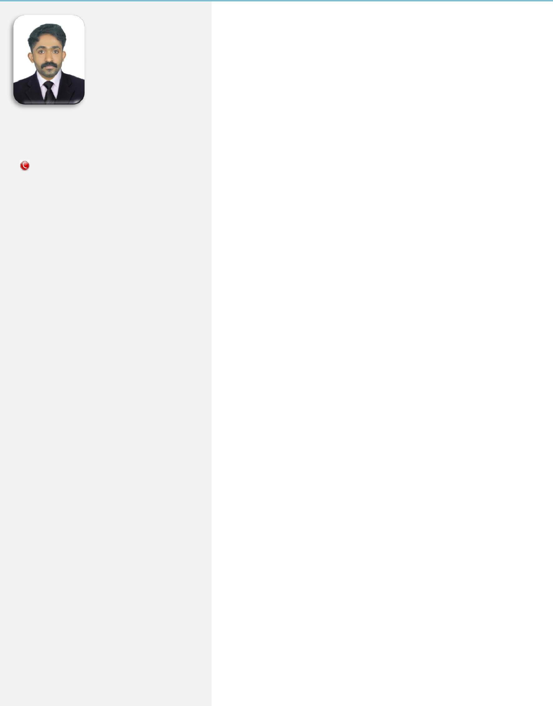
Rajesh

Contact Details

rajesh-394473@2freemail.com

Personal Information

Date of Birth | : 05 January 1994 (25Y)
Gender | : Male
Marital Status | : Unmarried
Nationality | : Indian
Religion & Caste : Hindu, Nair

Language Known : Malayalam, Hindi, &

English

Declaration.

I hereby declare that ,the above information are true to the best of my knowledge an belief and can be supported by the certificates in originals in case of any requirements

Date: With

19/09/2019 Regards
Rajesh
Place:

Velur Sign

CAREER OBJECTIVE

To build a strong career in the industrial Sector and improving the slandered Of the firm by involvement of my hard work in all field of the job given to me and energizing my surroundings to achieve the highest expectation of the firm.

PERSONAL SKILLS

- Comprehensive problem solving abilities

- Good Team Member and Ability to Learn Quickly

- Adaptable and Flexible to Varying working Enviourment

- Ability to transform Concept to Reality

- Initiate creative ideas to improve work process

ACCADAMIC QUALIFICATION

In 2009 : Completed S.S.L.C under Board of public Examination board, Kerala.

In 2013 : Completed Plus-Two under Board of Senior Secondary Examination, Kerala In Commerce.

And Now : Waiting for the Result of Graduation In Bachelor of Commerce(Finance) from Calicut University ,Kerala

PROFFESSIONAL QUALIFICATION

In 2019 : Completed Diploma in Practical Accounting ,GST and GCC VAT under National Centre for Labor and Learning (Certificate No.200596)

COMPUTER PROFICIENCY.

- Tally Erp 9
- Comprehensive Knowledge in M.S.Office

Working experience

CURRICULUM VITAE
Work Experience
Total Experience : 2.5 Years as Accounts Professional

Company Profiles

Period of Work : 01/08/2015 to 31/01/2017.
Designation : Accounts Assistant
Roles & Responsibilities

- Responsible for entire Accounting / Document Management and clerical jobs of the company

- Keep and track all company related documents like, Proposals, Purchase orders, and retrieve them in no time, when required by the relevant employees
- Recording of expenses & Purchases and materials delivery
✓ Follow ping of Account Receivable & Payable
- Preparing Stock reports with help BIN Card Stock Register

- Receiving Quotation & Preparing Purchase orders

Period of Work : 01/03/2017 to 31/03/2018
Designation : Accountant
Roles & Responsibilities
- Maintaining the books of accounts up to finalization

- Receipt, issue and inventory control of material

- Bank deposits, Payments and reconciliation

- Preparation of Month end reports, Yearend reports

- Evaluate monthly profit and loss account

- Checking vouchers with supporting documents

- Checking all the tax related documents

- Preparation of Vouching Notes

- Preparation of Payroll

- Preparation of Depreciation statements

- Follow Up Outstanding Debtors

- MIS Reporting

