Curriculum Vitae

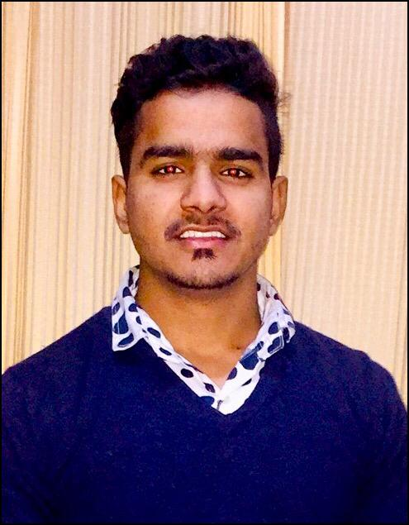

Harwinder
Email: harwinder@2freemail.com

POST APPLIED FOR: "ACCOUNTANT"

CAREER OBJECTIVES:

To join a progressive organization where I can work in a challenging atmosphere, make my significant contribution while developing my skills further, which would provide adequate growth opportunity and a sense of responsibility.

ACADEMIC CREDENTIALS

- Completed B.com from St.Soldier law collagein 2018 with 70 % also having internship for one month with Max life Insurance company.
- Senior Secondary Examination(P.S.E.B) in 2015,Khambra ,Jalandhar.
- Secondary Examination (P.S.E.B) in 2013, Chitti Jalandhar.

PERSONAL VITAE

Gender: Male
DOB: 14 December 1997
Hobbies and Interest: Sports,Listening to Music,Reading Books.
Languages known: English, Hindi & Punjabi
Marital status: Un-merried
Nationality: Indian

ORGANISATIONAL EXPERIENCE

Merchants (Jalandhar)
(june2018 to till date)

(As aAccountant)
Key Accountabilities Handled:

- Fully responsible for handling cash,reconcilations,collections and accounting.
- To verify and pass all expenses vouchers and ensure timely updating of the books of accounts.
- To track availability of funds in bank accounts, place adequate interbank transfers, procure information on bank balances, procure banks statements and prepare necessary bank reconciliation statements.
- To effectively close the monthly accounts on timely basis.
- To update the account entries in Catpro software
- Ensure any other duty that may be assigned from time to time.
- Maintain adequate records of cheques issued and ensure timely updation of the entries in the books of accounts.
- To make MIS on monthly basis.
- To make export invoices and e way bills.
- Working on Gst return and Tds return.
- Maintain adequate records of cheques issued and ensure timely updation of the entries in the books of accounts.
- To timely disburse cash/cheques to internal, external customers.
- Making salaries slips on real pack solution software and Distributing Salaries to Workers.

Innocent Hearts School (Jalandhar)
(January 2018 to june 2018)
(junior Executive Accountant)

Key Accountabilities Handled:

- Handling petty cash expenses of all branches.
- Vendor Management, Compliance Management, Registration and amendment
- Reconciliation of statements
- Registration and fees management
- To update the account entries in realpack solution software
- Daily account tally
- Timely disburse cash and cheques.
- To verify and pass all expenses vouchers and ensure timely updating of the books of accounts.
- To track availability of funds in bank accounts,place adequate interbank transfers,procure information on bank statements and bank balances.
- Maintain daily day book and submit to the Finance incharge.

COMPUTER CREDENTIALS

Software:Ms-Office (Word, Excel, PowerPoint), Tally ERP 9.0, Visual Catpro, BUSY Business accounting softwsare,Realpack solutions, THING Software (for accounting and retail).
Application/OS:Internetand E-mail.

PERSONAL STRENGHTHS
- Integrity , Dedication, Fairness, Flexibility, Customer Service, Team works, Leadership
- Time Management "I do right thing, right time, right Place"
- the ability to motivate people ,good spoken and written communication skills
- the ability to plan and priorities your own work and other people's
- an understanding of computer systems and cash registers, for some jobs
- Calmness under pressure ,decision-making ability, accuracy with record keeping ,accounting skills.

I am confident enough of my ability to work in a team or independently. I hereby solemnly affirm that the information provided by me is true to the best of my knowledge.Ifyou will give me opportunity to do this work I will do my best.

