Ridhima (Cloud Computing) (Present in Dubai)
Career Objective: Highly skilled Cloud Computing Engineer has exceptional development ability and extensive knowledge of Big Data, Hadoop and a strong ability to work with minimal supervision. Has a Bachelor’s Degree in Computer Application and one year of experience working as an Account Manager customer representative.
Additional Skill Set: Strong Organizational Skills, Data Entry, Computer Operator
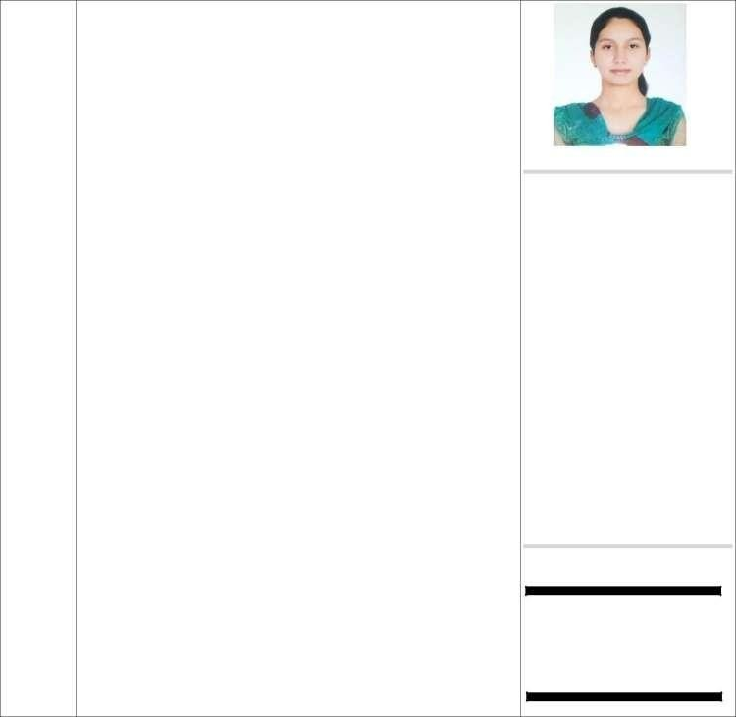 Experience

2018-07-
2019-08
Encore Account Manager

- Responsible Account Manager utilizing all company resources to solve client issues to the benefit of the client and the company.
- Assures success by being very familiar with company policies, working closely with customers on difficult issues and bringing in team help when needed.
- Dedicated to enhancing the client experience and increasing revenue.
- Monitored all client credit requests.
- Assisted in updating client sales and revenue records.
- Collected incoming client correspondence for the account manager.

Education

2015-07 – Guru Nanak Dev University
2018-04 Master of Computer Application

2012-07 – Guru Nanak Dev University
2015-04 Bachelor of Computer Application

Project Work
Training work: Studied cloud computing on salesforce.

Declaration: I hereby declare that all the details furnished above are true to the best of my knowledge and belief.

E-mail
ridhima-394505@2freemail.com
Date of birth
1994-06-25
Skills
Team Management
High skills to handle the team with patience and care.

Confident and Smart Worker

Able to handle things smartly. Always try to do things in new and with creativity instead of same monotonous

Ridhima

