ALEXANDER
Alexander-394511@2freemail.com

Key Skills  Store/ Brand Management  Retail Operations Management  Budgeting & Forecasting  Sales &Marketing / Business Development  Market &TrendsAnalysis  Customer Retention & Revenue Maximization  Pricing & Promotions  Supply Chain / Logistics/ Distribution Management  Team Building & Leadership | Performance-driven Professional, talented in synergizing business and operations towards building brands in a multi-cultural environment  Targeting assignments in Retail Operations/ Retail Sales and Brand Management with an organization of repute preferably in African/ Gulf/ European countries
 | Profile Summary
- Versatile Professional offering nearly 26years of experience in Retail & Sales Operations, and Brand &Customer Relationship Management with a verifiable record of building strong relationships and achieving customer satisfaction in competitive markets
- Excellence in managing retail operations entailing customer facilitation, stock management, maintaining minimum balance quantity of each product, undertaking necessary indenting on stock count, as well as managing merchandising mix
- Exposure in managing team & accounts and meeting / growth, customer segmentation, product positioning, sales cycle/ brand management and client exceeding targets relating to revenue retention & acquisition
- Expertise in conducting industry & market/ trends analysis, developing and implementing growth strategies and sales development plans thereby identifying commercial drivers to assist business planning and brand communication for products / services
- Pivotal in the launch of 7 stores in Egypt as per schedule
- Consistently delivered customer retention strategies & promotional plans and contributed towards enhancing business volumes & growth and achieved profitability norms to scale-up market share and maximize revenue
- Outstanding communication & leadership skills, known for establishing and sustaining valued networks and creating strategic alliances
Timeline
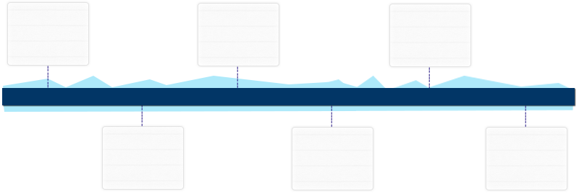
as Country Head, Egypt –Cairo

MM’09 – MM’16
Nov’97 – Apr’99
as Area Manager– Riyadh, KSA
Mar’95 – Oct’97
Jan’93 – Feb’95
B.Com. + MCom.
Since 2016
1991 & 1995
Retail Area Manager, KSA - Jeddah
as Sales Executive
as Area Manager
Education  Selected Achievements | - M.Com. from Saurashtra University, Gujarat, India in 1995  - B.Com. from Sardar Patel University, Gujarat, India in 1991  - Led the operations from scratch to a multi-million turnover annually  - Successfully launched Babyshop brand in the Egypt  - Recognized & appreciated by  - Territory Heads for the passion, commitment & creative thinking in launching the store and bringing new ideas on board  - GM Territory for overachieving the targets consistently for the store managed  - Minimized 5% staff costs and warehouse costs by 4.5%  - Successfully achieved 100% of budgets and targets in challenging environment  - Peculiarity of coordinating buying, promotions with local suppliers like Avent, Graco, Chicco, Fisher Price, Mattel in Egypt  - Acknowledged as member of the team which developed internal staff development programme for Future Managers (TMP)  - Showcased excellence in turning around a store in terms of business  - Spearheaded the company’s biggest store in Riyadh, Abdullah Street  - Successfully managed all the big shops of the company in prime malls and stand alone in Riyadh  - Developed maximum number of managers inside the system from sales staff in span of 3 years  - Established the new store In Abha, KSA
Work Experience | Growth Path/ Deputations:  1997 – 1999: Area Manager– Riyadh, KSA  1999 – 2016: Country Head, Egypt –Cairo  2016 – Present: Retail Area Manager, KSA - Jeddah  Key Result Areas:  - Exploring potential business avenues & managing retail & store operations for achieving the business targets; initiating market development efforts and increasing business growth  - Administering business and P/L operations of the group  - Analyzing latest marketing trends & tracking competitors’ activities and providing valuable inputs for fine-tuning marketing strategies; determining market opportunities for brand expansion  - Formulating & implementing budget and plans for retail operations; nurturing long-term customer relationships and mentoring the team to practice the same  - Managing the product pricing, promotions, monitoring seasonal sell through, product launches,markdowns and tie-up with malls  - Creating periodic financial & sales reports to identify trends and ensuring stores are on the correct growth curve; determining appropriate staffing levels and identifying ideal marketing expenditures  - Enhanced customer shopping experience by educating them on usage of devices/ applications and digital assets  - Monitoring inventory levels to determine the need for stock supply at each retail outlet; directing and supervising retail staff across several retail outlets to ensure they meet set objectives  - Interfacing with Store Managers and other retail staff to communicate relevant information; preparing necessary reports by collecting and analyzing information  - Identifying and evaluating improvement areas & implementing measures to maximize customer satisfaction levels  - Delivering high quality services, resulting in customer delight and optimum resource utilization for maximum service quality; driving and leading the team to achieve targets and goal sheets given by the company  Highlights:  - Developed business models and strategy for start-ups, roll-outs and scale-ups  - Implemented sales promotion plans & new store concepts to generate sales for achievement of targets; coordinated the in-store promotional activities for new releases & special products  - Conceptualised visual merchandising displays, windows & design of retail outlets for maintenance of a high-end store image  - Planned infrastructure/facilities, renovation, development and expansion in stores & sustained profitable operations with focus on marketing  - Structured & implemented monthly trade schemes as per market demand to boost sales trend & buying pattern; designed and executed marketing events for increasing sales  - Maximized the sales by changing the retail operations (warehousing &store operations)  - Successfully opened 6 new stores in a new mall  As Sales Executive from Mar’95 – Oct’97  as Area Manager from Jan’93 – Feb’95  Date of Birth: 13thFebruary 1969  Languages Known: English, Hindi, Konkani, Gujarati & Arabic (Basic)  Nationality: Indian  Passport Details: T4611453 ( Valid till Feb 2029)  Marital Status: Married  No. of Dependents: 2  Driving License: Valid driver’s licence – India, Egypt & KSA
Nov’97 - Present

Previous Experience

Personal Details

