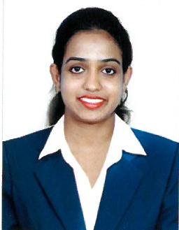
CURRICULAM VITAE

SHALINI
E-Mail- shalini-394518@2freemail.com

Objectives:

Seeking a position as Customer service executive, having excellent interpersonal skills with effective relationship with customer, believe in timely delivery of individualized solution to client.

Educational Qualification:
Diploma in Chemical Eng. from Technical Educational Board, Karnataka, India - 2013
PCMB (SCIENCE) fromPre-University Board, Karnataka, India – 2009
SSLC from Secondary Education Board, Karnataka, India - 2007
Work experience and Accomplishments:

.
July 2016 to April 2019
Customer Service Executivecum Senior Process Executive (Data Entry)

Duties and Accomplishments:
- Answering calls and providing information.
- Responsible for interacting with the clients and solving their queries
- Maintaining the records of customer interactions and follow up with the clients
- Provided feedback of the clients to the concerned departments and authorities so as to improve the services.
- Consolidate and optimize available data warehouse infrastructure and fetch data from different files.
- Import all the source files to SQL server application to analyze data from files and to identify the valid data.
- Implement ETL processes and functioning of analytics lad as well as client reporting environment and dashboard.
- Load finite data to the Diablo.

Skills:
- Communication
- Organization
- Patience
- Reliability
- Leadership
- Ability to multitask

August 2014 to January 2016
Receptionist

Duties Performed:
- Greeting clients and visitors with a positive, helpful attitude.
- Providing excellent customer service
- Scheduling appointments
- To record the patient records
- Answering, forwarding, and screening phone calls

June 2013 to May 2014
Junior chemist

Primacy Industries Limited is one of the world’s leading manufacturer of innovative, quality scented candles and aerosols.
Duties Performed:
- Prepare test solutions, compounds, and reagents for laboratory personnel to conduct test and also checking the melting point of the raw materials.
- Develop, improve, and customize products, equipment, formulas, processes, and analytical methods.
- Compile and analyze test information to determine process or equipment operating efficiency and to diagnose malfunctions.
- Maintain and update thorough and detailed laboratory procedures records and results.

Computer Skills:
Well versed withWindows, MS-office applications, Tally, Internet & other software applications.

STRENGTHS:
- Hard worker, Ability to cope with excels in the work place.
- Good planner & Co coordinator.
- Easily approachable, Adaptation to change.
- Ready to work in Pressure
- Integrate new learning into practice.
- Completion of work in a time efficient manner.

Personal details:
Date of Birth : 10th April 1991
Visa Status : Visiting Visa
Visa Validity :Valid Till 7 October 2019
Nationality : India
Marital Status : Married
Languages Known : English, Hindi, Kannada, and Konkani
Hobbies : Listening toMusic, Sports

Yours sincerely,
Shalini

