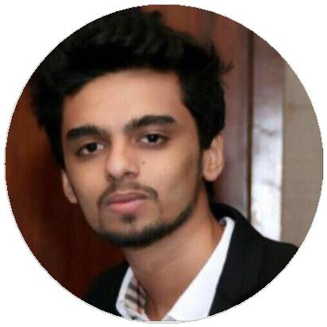

Armaan-394578@2freemail.com

Abu Dhabi, United Arab Emirates

SOFTWARE

Advanced MS Excel

MS Powerpoint & MS Word

Adobe Design Suite

Metatrader 4

LANGUAGES

English

Full Professional Proficiency

Hindi

Native or Bilingual Proficiency

Gujarati

Professional Working Proficiency

SOFT SKILLS

Eﬀective oral and written communication

Strong analytical ability

Team Player

Quick Learner

Curiosity Integrity

Proficient with

technology

Logical reasoning

Armaan

Financial Analyst

A creative and results driven individual with a firm grasp on core financial principals allied with hands-on valuable experience in a dynamic corporate environment. Armaan has the ability to work independently or as part of a team.

EDUCATION

Bachelors in Management Studies
M.K Sanghvi College of Commerce

06/2015 – 03/2018 Mumbai University Courses

Major: Finance

HSC
M.K Sanghvi College of Commerce

06/2012 – 02/2014 MSBE

WORK EXPERIENCE

Financial Associate

03/2018 – Present Mumbai, India.

Gained solid theoretical base of business management and enough exposure to the real time capital market trading. Working a busy and high volume environment driving consistency and best practices across all areas of work.

Responsibilities

Maintaining an independent and secure record of the clients and monitoring consistently the progress of their investment securities

Providing accurate financial information to colleagues and senior managers. Incharge of Managing and supporting the ledger team

Execute trades in accordance with firm policy and according to all regulatory rules and procedures

Handling post market trade confirmations.

CERTIFICATIONS

CFA Level II Candidate (06/2019 – Present)

CFA Institute

CFA Level I Certification (06/2018 – 06/2018)

CFA Institute

Accounting Fundamentals Certification (07/2019 – 07/2019)

CFI Institute

PROFESSIONAL SKILLS SUMMARY

Company Ratio Analysis | Financial Modeling | Familiar with GAAP and IFRS statutory accounting principles | Elementary Economic Concepts | Working of financial securities viz. equity, fixed income, swaps, ETF's, hedge funds | Forex Trading | Brief Understanding of Hypothesis Testing | DCF and Capital Budgeting | Laws Governing Shariah-Compliant Investments

INTERESTS

Reading | Sketching | Technology | Design | Football | Current Aﬀairs & Politics.

