CURRICULUM VITAE

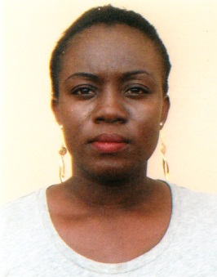
AMARA
EMAIL: amara-394586@2freemail.com
DUBAI- U.A.E

WAITRESS
OBJECTIVES:
To work as a waitress in a challenging environment, contributing enthusiasm, dedication, responsibility, and good work ethic, combined with a desire to utilize my customer service skills obtained through experience as a waitress in restaurant.

PERSONAL EXPERIENCE:

- Waitress in Nigeria (3-years)

DUTIES &RESPONSIBITIES:
- Welcoming customers into the restaurant
- Taking orders for food and beverages from customers
- Laying tables and reclining area for customer’s satisfaction
- Assisting Chefs in preparing Menus
- Handling Cash paid by the customers
- Attending to customers over the phone orders
- Working hard for restaurant runs smoothly
- Assisting other staffs when needed
- And handling other roles as may be demanded of me by my superior

SPECIAL SKILLS:
- Welcoming guests
- Demonstrating menu knowledge
- Answering questions
- Up selling specialty items
- Describing dishes
- Taking orders (beverage and food)
- Handling complaints
- Ensuring guest satisfaction
- Good interpersonal skills
- Ability to work under pressure

PERSONAL PROFILE:
- Gender : Female
- Date of birth : 29-12-1994
- Nationality : Nigeria
- Marital Status : married
- Visa status : sponsor visa
- Language : English
EDUCATION:

- OND (NwaforOrizu Collage of Education)
DECLARATION:
I certify that the above are true and correct to the best of my knowledge and ability. If given a chance to serve you. I assure you that I will execute my duties for the total satisfaction of my superiors.

