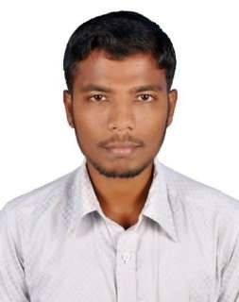
AMEEN

MECHANICAL ENGINEER (QUALITY CONTROLLER)
E-mail: ameen-394627@2freemail.com
Tamil nadu, India.

Career objectives:
A responsible and challenging entry level position that will utilize my education and background, expand my knowledge, and offer opportunities for personal and professional growth.

Educational Qualification:
Completion of bachelor degree in engineering and technology in the department of MECHANICAL ENGINEERING with FIRST CLASS at ANNA UNIVERSITY, CHENNAI on 2017.

Work Experiences:
Recent experience:
Quality controller
Singanallur, Coimbatore.
JULY 2018 – JUNE 2019.
Roles & Responsibilities:
- To check the quality of the material or products (job).
- By using instruments like gauges, budge rod and hand grip gauge etc…
- Production department produce the spur gear and we can check the quality.
- By using computer numerical control (CNC) & vertical machining center (VMC).
- Spur gear is our major product and it is made up of cast iron.
- It is used in many industries like automobiles.
- To measure the diameter of the product by measuring gauges.
- There are two gauges “internal & external diameter measuring gauges.
- Fix the tolerance limit for required diameter.
- Spur gear having teeth and it contains some distance to measure.
- External diameter needs upto the +-0.3 tolerance limits.
- Using a rod grip to measure the perpendicular teeth distance.
- Also using a rod role (budge) to measure gear hole.
- Finally, the product (job) is transferred to the quality assurance section.

Previous experience:
Training engineer (coordinator)
Cuddalore.
JULY 2017 – JUNE 2018.
Roles & Responsibilities:
- Working as a training engineer to learn following duties.
- Working as a site coordinator to scheduling the duties.
- Handling construction site project with coordination.
- Knowledge in handling of machineries like lathe (cnc), grinder and driller.
- Working with efficient plumbers & electricians as an helper.
- Gaining of knowledge in pipeline fittings & joints.
- To use the fitting & joints for required pipeline with definite dimensions.

Academic projects:
- MINI PROJECT: Power generation using speed breakers.
- MAIN PROJECT: Drain water cleaner by chain sprocket mechanism.

Software exposure:
- Basic knowledge in PRO-E (Creo) & AutoCAD software.
- Good knowledge in Microsoft office (Word, Power point & excel).
- Proficient in Microsoft Windows (8, 10) operating systems.

Personal details:

Date of Birth : JUNE, 1996

Gender : MALE

Marital status : UNMARRIED

Religion : ISLAM

Nationality : INDIAN (TAMILNADU) Languages known : ENGLISH, TAMIL

Declaration:
I hereby confirm that the information furnished above is all true to the best of my knowledge.

DATE:

PLACE: (AMEEN )

