EXPERTISE / SKILLS

Primavera P6

Construction Computer Software

(Candy CCS)

Microsoft Office

AutoCAD

Scheduling & Project Planning

Resource Loading for Individual

Projects

Extremely Organized

Self-motivated Resourceful Team Player Good Leadership Skill

EDUCATION

Bachelor of Science in Civil

Engineering

Mapua Institute of Technology

2008-2014

Our Lady of Carmel School
2004-2008
2nd Honorable Mention

Carretonan Elementary School 1998-2004

Class Valedictorian

LICENCES

Registered Civil Engineer

Professional Regulation Commission

December 2014

Registered Master Plumber

Professional Regulation Commission

February 2017

JOCELYN
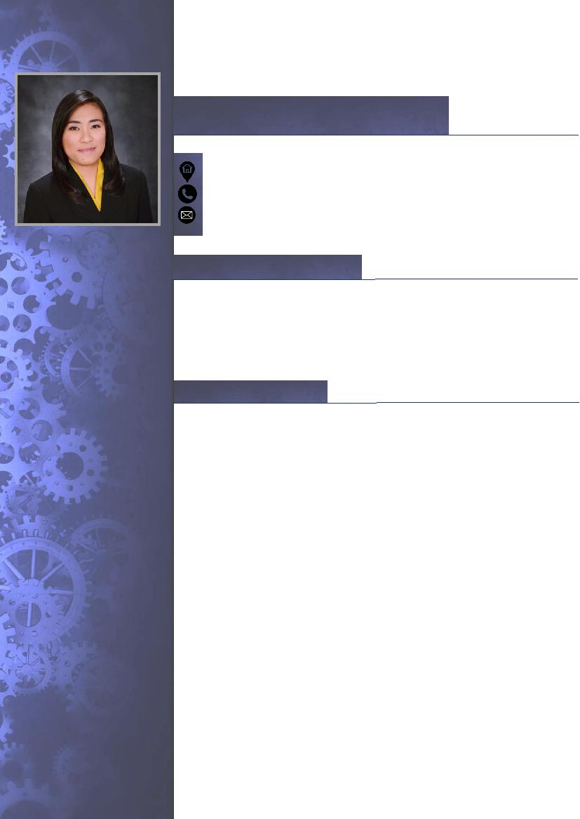

PLANNING ENGINEER

Jocelyn-394649@2freemail.com

PROFESSIONAL PROFILE

A highly talented and dedicated Planning Engineer seeking for a position where I could practice my skills and knowledge, and take on challenging, creative, and diversified projects. Capable of working independently with minimum supervision, and committed to providing high quality service to every project with focus on health, safety and environmental issues.

WORK EXPERIENCE

- PLANNING ENGINEER

Contracting company in Dubai, UAE

May 2017 – Present

PROJECTS (DUBAI INTERNATIONAL AIRPORT):

  - DP/INF/16C - South Runway Rehabilitation & Associated Works (Refurbishment of Taxiways)

  - DP/INF/16B - South Runway Rehabilitation & Associated Works (Closure - Works within Runway Strip)

  - DP/INF/16A - South Runway Rehabilitation & Associated Works (Pre-Closure - Works outside Runway Strip)

  - SP330 - Support Facilities South Side Super Gate

  - WO#001 - GSE Fuel Trucks Staging Area

  - WO#009 - Widening of West GSE Road

JOB ACCOUNTABILITIES:

- Develop contract programs / baseline schedule and resourcing in conjunction with the Project Leads / Planning Manager / Commercial Department.

- Measure and monitor site progress, update schedules.

- Prepare and review weekly / monthly / quarterly reports and forecasts (Labor, Plant, Staff, and KPI).

SEMINARS

&

TRAININGS

“SITE SAFETY ORIENTATION”

MDC - Philippines

July 2015

“CONSTRUCTION OCCUPATIONAL

SAFETY & HEALTH (COSH)”

Safeways Consultancy & Safety

Services - Philippines

September 2015

“TIME MANAGEMENT & STAYING FOCUSED”

Dovetail – Dubai, UAE

April 2018

“ECITB IHSP – ADVANCED &

SUPERVISOR COURSE”

Engineering Construction

Industry Training Board -

International Health &

Safety Passport

Dubai, UAE

April 2018

BASIC

INFORMATION

Age: 28

Birthday: August 20, 1991

Birth Address: Alabang

Muntinlupa, Philippines

Gender: Female

Civil Status: Single

Nationality: Filipino

Religion: Christian

  - Assisting in claim preparation with detailed schedules, records, and analysis.

  - Liaise with Planning Manager / Project Managers for the smooth functioning of planning function on sites.

  - Prepare weekly look ahead to maintain objectives.

  - Prepare Progress S-Curves, histograms, and graphical reports.

  - Analyze gaps between the planned and actual progress and highlight the areas of concern which required action of the associate task member.

  - Use critical path analysis to determine the vital key activities and their impact on the project completion date.

  - Participate in project meetings and discussions with the Client / Consultant as required. Perform other duties and responsibilities as may be assigned from time to time.

- ENGINEER II / SITE ENGINEER

Department of Public Works & Highways (DPWH) Valenzuela Pumping Stations Project

May 2016 – May 2017

- FIELD ENGINEER

Makati Development Corporation (MDC) Circuit Mall & BPO1 Project

July 2015 – April 2016

REFERENCES

I hereby certify that the above information are true and correct to the best of my knowledge and belief.

JOCLEYN

