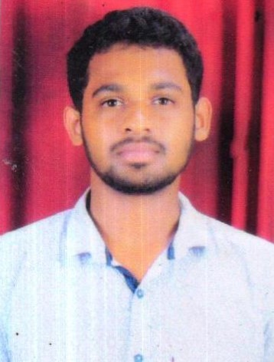GAGAN

DOCUMENT CONTROLLER / MANAGEMENT SECRETARY.

E-mail id : gagan-394672@2freemail.com

CAREER OBJECTIVE:-
I aim to be recognized as an efficient and competent individual having good interpersonal and managing skills. Being a hard worker with a positive attitude, I aspire to prove my talent with teamwork and efficient results of organization that leverages my strengths and enables me to become a valuable and dependable asset for the organizations success, along with providing me a platform for professional and personal growth.

STRENGTHS:-
- Administrative Skills.
- Reporting Skills.
- Willingness to learn.
- Good communication skills.
- Team working skills.
- Organization and time management skills.
- Assertiveness.
- Tact, discretion and diplomacy.
- Comprehensive problem solving abilities.
- Excellent verbal and written communication skills.
- The ability to be proactive and use your initiative.
- The ability to use standard software packages and to learn bespoke packages if required.
- Editing Skills.

ADDITIONAL SKILLS:-

- IELTS :- Band 5.5

COMPUTER SKILLS:-

- Microsoft office.
- Basic computer applications.

EDUCATIONAL QUALIFICATION:-

Bachelor Degree : Bachelor of Arts (Criminology, Psychology, and Sociology) University of Mysore.
PUC(12th/(+2)) : Pre-University college Srimangala (Pre-university Board, Bangalore).

S.S.L.C(10th) : J C school Srimangala (Karnataka Secondary Education Examination Board, KSEEB).

WORK EXPERIENCE:-

in LIBYA

Duration : October 2017- Till Date

Position : Document Controller/Management secretary.

RESPONSIBILITIES:-

As

DOCUMENT CONTROLLER:-

  - Responsible for controlling all documentation related activities in a project.
  - Support and coordinates with discipline with administration and control.
  - Ensure all technical documents, such as reports, drawings and blue prints, are collected and registered in the system.
  - Review and update technical documents.
  - In carry/dispatch/Updating Contracts/ Bill details.
  - Preparation of Report.
  - Control and maintain project Record of incoming/outgoing project documents.
  - File documents in physical and digital records.
  - Retrieve files as requested by employees and clients.
  - Print and distribute documents as necessary.
  - Work with documents and records across various departments, including human resource.
  - Maintain confidentiality around sensitive information and terms of agreement.

As

MANAGEMENT SECRETARY:-

  - Deal with telephone and email enquiries, using an email system.
  - Photocopy and print various documents, sometimes on behalf of other colleagues.
  - Produces information by formatting, inputting, editing, retrieving, copying, and transmitting text, data.
  - Organizes work by reading and routing correspondence; collecting information; initiating telecommunications.
  - Maintains department schedule by maintaining calendars for department personnel, arranging meetings, conferences.
  - Completes requests by greeting customers, in person or on the telephone, answering or referring inquiries.
  - Prepares reports by collecting information.
  - Secures information by completing database backups.
  - Provides historical reference by utilizing filing and retrieval systems.
  - Organize and store paperwork, documents and computer-based information.
  - Create and maintain filing and other office systems.
  - Keep diaries and arrange appointments.
  - Maintains technical knowledge.
  - Maintain office procedures.
  - Handle confidential documents ensuring they remain secure.
  - Managing databases.
  - Prepare, submit employee timesheet.
  - Schedule and attend meetings, create agendas and take minutes.
  - Sort and distribute incoming post and Organize and send outgoing post.
  - Arrange training for staff members.

Duration : September 2016 to September 2017 Position : Subject matter expert (SME).

RESPONSIBILITIES:-

  - Provide accurate and appropriate information to members and providers in response to inquiries.
  - Addressed customer concerns timely and accurately.
  - Assist members of the team.
  - Monitor daily activity and function of the team.
  - Coach the agents on improving customer interactions.
  - Achieving quality and attendance goals.
  - Sometimes assist with inbound and outbound activity.
  - Handle escalated supervisory type calls.

PERSONAL DETAILS:-

Date of Birth : 20-02-1993
Nationality : INDIAN
Marital Status : Unmarried
Languages Known : English, Kannada, Hindi, Malayalam, Tamil, Coorgi.

DECLARATION:-

I hereby declare that all the above mentioned information given by me is true and correct to the best of my knowledge and belief.

GAGAN

