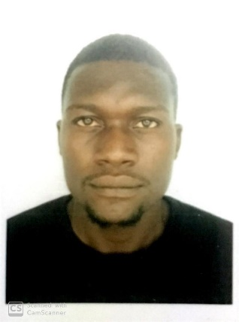

Email: Daniel-394699@2freemail.com
D A N I E L
OBJECT IVE

To be a valuable asset to my employer, contribute to achieving the operational objectives of the Organization at a maximum level with efficiency and effectiveness, work in a challenging environment which offers opportunities for growth and development, one that rewards creativity, initiative, superior performance, and where honesty and integrity are norms.

WORK EXPERIENCE
[February 2019]
Site Manager / Technical support

Tasks carried out;
- Excavation and Blinding of Shibang Machinery Base [SBM]
- Construction and Casting of 1.2m high Foundation Base for SBM
- Construction and Casting 12m high retaining and baffle wall

[November 2017]
Electrical Engineer at Odis Technology Co. Ltd.

Tasks carried out Nestle Nigeria, Agbara Factory;
- Installation Waste Water Treatment Plant.
- Building of Electrical Panel for Cooling Tower.
- Installation of Beam detector for ware house
- Installation of high bay.
- Laying and Termination of power and control cable for Chilled Water Tank Farm.
- Installation, laying and termination of power and control cable for Bosch Boiler.

[ February 2016]
Safety Officer
Task carried out;
- Risk Prediction
- Execute and carry out safety checks on personnel and equipment.
- Ensure smooth flow of work on daily basis without any safety gap.
- First Aider

[November 2016- October 2017]

Tasks carried out;
- Assisted in Lecturing West African Examination Council (WAEC) Physics students.
- Assisted in conducting practical sessions West African Examination Council for (WAEC) Physics students.
- Served as an academic mentor to some prospective university students.

[February-October 2016]
Graduate Internship

Works carried out;
- Installation of Industrial extractor fans
- Replacement of bad polyflow (Pneumatic pressure) hose.
- Installation of emergency exit lights.
- Installation of float switches.
- Safety officer
EDUCATION

- 2015: UNIVERSITY OF BENIN, EDO STATE.
B.Sc Electrical & Electronic Technology.
- 2008: BUNTINA SECONDARY SCHOOL, IGARRA, EDO STATE.
Senior Secondary School Certificate.
- 2002: GLORYLAND NURSERY AND PRIMARY SCHOOL. IGARRA, EDO STATE.
First School Leaving Certificate.

CERTIFICATION

February 2018: Health Safety and Environment (HSE 1, 2 & 3).
December 2010: Linstone Victory Computer (Computer Engineering and Data Processing)
January 2015: Save Accident Victims Association of Nigeria (SAVAN)
HOBBIES

- Reading
- Driving
- Teaching
- Researching
- Travelling
- Surfing internet
PERSONAL DATA

- Marital Status: Engaged
- Nationality: Nigerian
- Sex: Male
- Date of Birth: 6th March, 1990
- State of Origin: Edo State.
SKILLS

- Good teaching and impartation abilities.
- Proficient in the use of Microsoft office suite and the extensive use of the internet.
- Role execution before deadlines.
- Swift critical thinking and problem solving skills.
- Good computer skills.
- Excellent in reading, listening and writing in English Language.
- Good technical communication, interpersonal, analytical and presentation skills.
- Good listener, quick learner with positive attitude
- Result oriented, honest, self-motivated, detail-oriented, Performance driven and experienced in working as part of a team.
- Initiative to solve problems with high energy and a positive attitude.
- Ability to commit to the organization’s core values, mission, vision and programs.
- Managerial experience with increased responsibility and demonstrated skills.

PROFICIENCY

- Computer engineering: Software, Troubleshooting and Installation of different OS.
- Proficiency in the use of Microsoft Office suite 2003, 2007, 2010, 2013 and 2016.

- Proficiency in the use of Windows 2008, 2012, Windows XP, Windows 7, 8, 10 and MAC OS.
- Knowledge of graphic designing applications such as Corel draw, Photoshop etc.
- Knowledge of Computer Troubleshooting, maintenance and repairs.

REFREE

Available on request

