Work Experience

Jason

Jason-394706@2freemail.com

About Me
Age 24
Date of birth : July 27, 1995

April 3, 2019 – present
Office Assistant
- Analyzing and Summarizing Data
- Preparation of Protocol and Reports
- Filing and Distribution of Reports
- Installations of device for field works

July 7, 2018 - Sept. 29, 2018
Receptionist
ØWelcomes visitors by greeting them, in person or in telephone; answering or referring inquiries.
ØMaintains security by following procedures.
ØMonitoring logbook; issuing visitor badges.
ØContributes to team effort by accomplishing related results as needed.

Gender Civil Status

Skills
: Male
: Single

July 23, 2017 - June 30, 2018

- Knowledge in Microsoft Word & Excel
- Data Entry & Analyzing
- Customer Relation & Services
Marketing & Sales Service Assistant
- Preparation of Customers Requirements and Documenting.
- Monitoring the validity of (MSVS) Membership Verification

- Communication Skills
Status of buyers and Updating Records.
Ø

- Planning
- Creativity

Educational Attainment
vTertiary : Rizal Technological University
(2012-2016)
Analyzing/Scanning records before Filling the accounts
- Filing of Customers account loan through financing.
- Assisting Seminars conducted for the customers before inquiring a Housing Loan
- Collecting of Payments.
- Encoding records of payments and updating the masterfile daily.
Ø

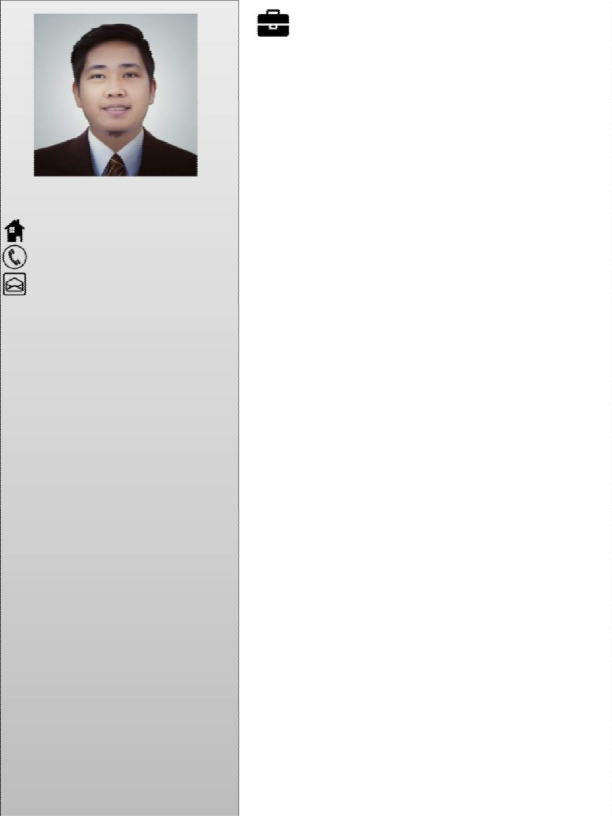
Graduate of Bachelor of Science and Business Administration
(Major in Management)
Boni, Mandaluyong City Philippines
vSecondary : Rizal High School (2008-2012)
Dr. Sixto Avenue Caniogan, Pasig City Philippines
vPrimary : Fransisco Legazpi Memorial School
(2002-2008)
Ugong, Pasig City Philippines.
Assisting Calls/Answering customers queries/Follow up customers payments before deadline.

October 2016 – March 2017
Trading & Investment Assistant
- Monitoring of accounts maturity & Updating Daaily Status
- Making calls for accounts renewal
- Monitoring daily stocks on Bloomberg System
- Updating Investors about the movements of stocks.
- Filling of Documents and daily transactions such as payments and receipts
- Bookkeeping Records of accounts.

