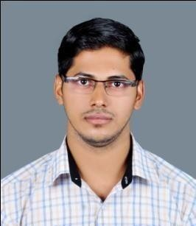
Hyder
Al Ain, UAE
Email : hyder-394716@2freemail.com

Career Objectives

I aspire to work in a dynamic, competitive and result oriented environment that will expose me to new challenges and enable me to grow by continuous innovation and research. As a part of a team as well as an individual, I hope to contribute to the growth of organization through my knowledge and skills. My academic studies have been streamlined in the field of Tourism and Airline Studies. I am a promising resource in my subject area. I am a self-starter and free to spend
Unlimited time for continuous improvement .

Work Experience

Currently working as a Travel Consultant in Abu Dhabi, U.A.E

- Check fair and availability for desired dates using Amadeus and Galileo
- Reserve the tickets upon customer confirmation
- Attend customer enquiries for price and availability
- Amend bookings on customer requests

in Kerala, India (01 October 2015- 31 August 2016)

Travel Consultant

- Check fair and availability for desired dates using Amadeus and Galileo
- Reserve the tickets upon customer confirmation
- Attend customer enquiries for price and availability
- Amend bookings on customer requests

in Kerala, India (05 April 2015 – 25 September 2015)

Travel Consultant (As a Trainee)

- Check fair and availability for desired dates using Amadeus and Galileo
- Reserve the tickets upon customer confirmation
- Attend customer enquiries for price and availability

Educational Qualification
Successfully Completed Bachelor of Commerce (B.COM) from, Bharathiar University, TAMIL NADU, INDIA (June 2012-March 2015)

Successfully Completed HSE (Kerala Higher secondary Board) with specialization in Commerce, KERALA, INDIA (June 2008-March 2010)

Successfully Completed S.S.L.C (Kerala State Board) from, M.S.M.H.S.S Kallingal paramba, KERALA, INDIA (March 2008)

Professional Qualification

IATA/UFTAA Foundation passed with distinction Montreal Canada, March 2011

Personal Details
Date of Birth : 15.08.1990

Nationality : Indian

Languages : English, Malayalam, Tamil, Hindi, Arabic
Visa Status : Residence visa

Sex : Male

Religion : Islam

Marital status : Married
Hobbies : Reading, Listening music, and Traveling

Outstanding Qualities

Young, dynamic, creative, hardworking, excellent team work and dedicated in improving excellent service.

