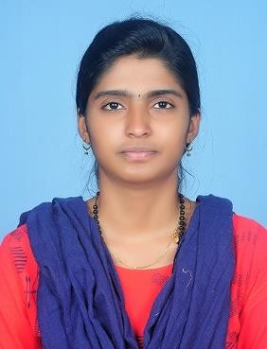 | DRISYA
PROFILE  To grow with a leading organization that utilizes my abilities to the fullest extent possible, helping me realize and develop my potential and be a part of a team that scales great heights through continuous learning process and utmost dedication.  CONTACT  Email : drisya-394728@2freemail.com  PERSONAL PROFILE  Date of Birth: 20/08/1996 Nationality: Indian Marital Status: Married  Visa Status: Husband Sponsored  PROFESSIONAL REGISTRATION  Tamilnadu Pharmacy Council – Chennai, India | EDUCATION  Bachelor of Pharmacy- 2018  JSS College of Pharmacy, Ooty, TamilNadu, India  Higher Secondary - 2014  St. Ann’s Girls Higher Secondary School, Ooty, TamilNadu, India  SSLC -2012  Kendriya Vidyalaya – Ooty, TamilNadu, India  WORK EXPERIENCE  Position Held – Pharmacist May 2018 – May 2019  Responsibilities:  - Providing advice about health issues, symptoms and medications in response to customer enquiries.  - Processing prescriptions and dispensing medication.  - Ordering and selling medicines and other stock.  - Meeting medical representatives.  - Marketing services.  ACHIEVEMENTS AND AWARDS  Secured third position in international level paper presentation entitled “FISH SKIN A NOVEL TREATMENT FOR EXTENSVE BURN INJURY”.  Secured third place in quiz competition in view of the Nilgiris Districts level wildlife week celebration conducted at Ooty.  Selected for state level match of throw ball - K.V.S. Chennai Regional Sports Meet)  SKILLS  Trained in handling analytical Equipments (HPLC, UV-VI Spectrometer, IR Spectrometer)  Patient Counseling & Inventory Control Excellent Organizational skill  Well versed communication in English, Hindi, Tamil, Malayalam  COMPUTER PROFICIENCY  MS OFFICE  CAPS (Computer Application in Pharmacy)

