 CAREER OBJECTIVE
To become a part of a reputed organisation in the oil and chemical sector where I can apply my skills and achieve my goals thereby resulting in improvement of my skills along with the betterment of the organisation .

 EDUCATION

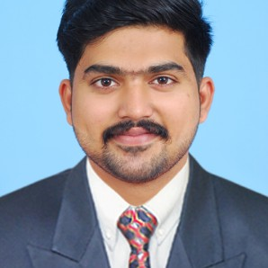

NOUHAR


Nouhar-394735@2freemail.com
 Deira, Dubai ,UAE

 SKILLS
INSTRUMENTATION WORKSHOP
A degree level and proven comprehensive skills in well and plant engineering operations Proﬁciency in working with computer software /IT tools Project management skills

 EXTRA CURRICULAR ACTIVITIES

- Attended for National Level Technical Symposium in CSIR & SSN college
- Participated as coordinator and volunteer in Technical functions.

JCT college of Engineering and technology
BE Petrochemical Engineering
6.59 cgpa 2019

Mambaram English medium school (Cbse)
12th grade 65%
2015

Sree Gokulam Public school ,vatakara
10th grade 90%
2013

 EXPERIENCE

INSTITUTE
30.07.2018 - 03.08.2018

INSTITUTE
KARAIKUDI
15.02.2018 - 16.02.2018

01.01.2019 - 01.02.2019

 PROJECTS

STUDY OF COMPLEX ANALYSIS OF RAWSALT FOR CAUSTIC SODA PRODUCTION
1 month ( 01.01.2019 - 01.02.2019)

 ACHIEVEMENTS & AWARDS

Nominee for the best project award of the year 2019 from JCT college of engineering
Certiﬁcate of Anna University in BE Petro chemical engineering with an overall CGPA 6.59

- Participation in social Welfare Activities

 INDUSTRIAL EXPOSURE

  - Fluid Control Research Institute
  - The Trancancore Cochin chemcials

 PERSONAL STRENGTHS
    - Quick learner
    - Team player
    - Critical Thinker

 PERSONAL PROFILE

Date of Birth : 29/11/1996 Marital Status : Single Nationality : India
Known Languages : English, Malayalam, Hindi , Tamil



 DECLARATION
I declare that the particulars given above are true to the best of my knowledge and belief.

