VASEEM
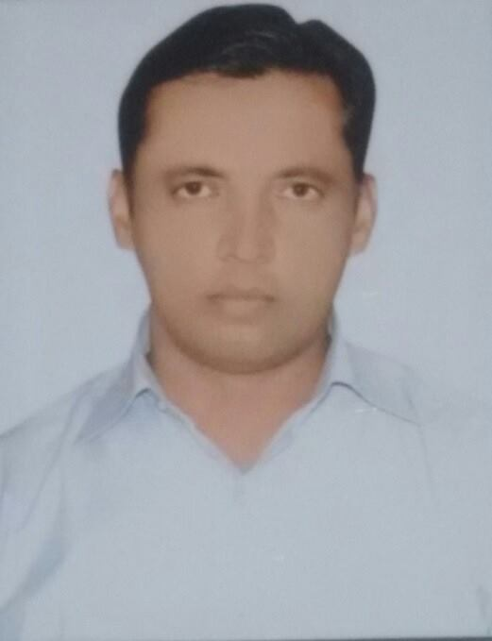
Email: vaseem-394762@2freemail.com

Career Objective
“To obtain a job with in my chosen field that will challenge me and allow me to use my academic qualification, analytical skills and past experiences in a way that is mutually beneficial to both myself and organization and allow for future growth and advancement”.
Academic Qualificatins
- B.A (Hons) Geography from AMU in 1998
- Intermediate (10+2) from AMU in 1995
- High School from U.P board in 1993

Professional Qualifications
- Master in Tourism Administration (M.T.A) from Aligarh Muslim University (A.M.U) Aligarh in 2002

Professional Experiences

Travel Consultant

Self employed

Job Profile 01st Jan 2016 to Present
- Giving advice on destinations and making arrangements for transportation, hotel accommodations, car rentals, tours, and recreation.
- Booking air tickets and get issued with the help of GSA
- Advising clients on weather conditions, restaurants, and tourist attractions.
- Providing information on customs regulations, required papers (passports, visas, and certificates of vaccination), and currency exchange rates.
- Consulting a variety of published and computer-based sources for information on departure and arrival times, fares, and hotel ratings and accommodations.
- Visiting hotels, resorts, and restaurants to evaluate the comfort, cleanliness, and quality of food and service for recommendations on travel experiences.
- Promoting services, using telemarketing, direct mail, and the Internet.

Jan. 2009 to Dec 2015
Sales Consultant
Job profile
- Responsible to increase sales in my territory by extending coverage
- Responsible for preparing market strategies & schemes to counter the competitor's activity in the territory, Research on related companies in the market
- Arranging advertising to promote the property
- Making appointments and showing buyers around a property
- Finding buyers in a position to proceed with purchase and willing to pay an acceptable price
- Played a stellar role in managing After-sales services including coordination with Installation Team, timely hand over
- Referring buyers to morgage arrangers for quotations and advice
- Instrumental in resolving customer queries related with Service and Billing issues.
- Accountable for All time billing of customer
- Challenging any objections with a view to getting the customer to buy
- Reviewing our own sales performance, aiming to meet or exceed targets
- Attend team meeting and sharing best practice with colleagues

In Dubai, UAE August 2007 to September 2008
Business Development Executive
Job profile
- Identifying, researching and targeting new business prospects.
- Liaising with new and existing clients over the phone and meeting them face to face.
- Gaining new appointments from hot and cold leads.
- Managing and maintaining databases of potential clients.
- Developing strong working relationships with prospective new clients.
- Producing monthly pipeline reports for management purposes.
- Providing support to the sales and marketing team through a variety of additional activities.
- Pitching products and/or services
- Maintaining fruitful relationships with existing customers
- Working in the Telesales Department of the bank, handling the outbound sales for Credit cards, Balance transfer and smart cash
- Coordinating with the credit department for quick approvals
- Developing new areas to generate new business.
- To achieve the sales / revenue target from new clients
- To give regular feedback on market conditions, competition and other factors influencing sales
- Attend team meeting and sharing best practice with colleagues
in INDIA April2004 to March 2007
Sr. Customer Support Representative
Job profile
- Assists the Customer Service Representative (CSR) with difficult cases.
- Ensures delivery of excellent customer service through fast and accurate processing of orders, communication, and coordinating with other departments to resolve inquires.
- May assist management in ensuring performance goals are met.
- Builds and maintain business relationship with clients by providing prompt and accurate service so as to promote customer loyalty.
- May mentor or give direction to junior team members and provide training on best practices.

Personal Details

Date of birth : 04th August 1976
Nationality : Indian
Marital Status : Married
Languages : English, Hindi and Urdu
Date of issue : 04/03/2015
Date of expiry : 03/03/2025

Date
Place Vaseem

