Curriculum Vitae  ASHICK  Ashick-394763@2freemail.com  VALID UAE DRIVING LICENSE | 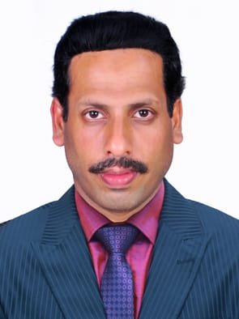
Post Applied For : P.R.O (Public Relation Officer) 9 year experience

OBJECTIVE
To be associated with a progressive organization to become a part to the team that dynamically works toward the growth of the organization to utilize my complete potential and creative skill pushing myself for the limits on order accomplish of task for the betterment of the company.
PROFESSIONAL EXPERIENCE
- AUTO SPARE PARTS TRADING in DUBAI
Period: November 2009 – Till

- PUBLICATIONS AND PRINTING in DUBAI
Period: September 2003 – August 2008

- Controlling and handling all works for different government departments (Ministry of interior, Ministry of labour, Municipality, Tasheel, Economic, Dubai Court, Police Station, Embassies, etc.)
- Typing all the online service of various Govt. departments. (Ministry of labour, Thasheel,Medical GDRFA, Municipality, Civil Defense etc.)
- Typing all Department forms (Arabic & English)
- Handling company Trade License renewal and company Establishment Card etc.
- Preparing documents for Civil Defense also arranging for inspection.
- HR co-ordination.
- Assist the Department Manager, in the public affairs of employees and labours.
- Handling lease contracts (issuance and renewal).
- Renewal of company vehicles insurance and vehicles licenses.
- Ensure all visas. Medical and labour permits are up to date and arrange timely renewal.
- Renew, update and maintain all employees and their dependents ‘s visas, labour cards, and labour contracts in a timely manner to ensure that company’s records are up –to- date in the labour and Immigration Departments.
- Arrange processing attestation of employee qualifications as required.
- Maintain confidentiality of the company and keep the record of all employees documents.

Education (Academic)
Higher Secondary
[Kerala State Education Board, Kerala – India]

Technical Knowledge
- MS Excel
- MS Word
- General Computer Knowledge
- GDRFA
- Thasheel
- Medical
- Summary
Summary
Gender : |  | Male
Marital status : |  | Married
Nationality : |  | Indian
Date of birth : |  | 10/01/1976
Languages Known : |  | English, Arabic, Malayalam & Hindi
Visa Status :  Experience: |  | Employment Visa  9+ year
Driving License

- With valid UAE D/L
- Issued Place Dubai
- Issued Date 13-06-2011
- Expiry Date 21-09-2021

