Curriculum Vitae
Abbas

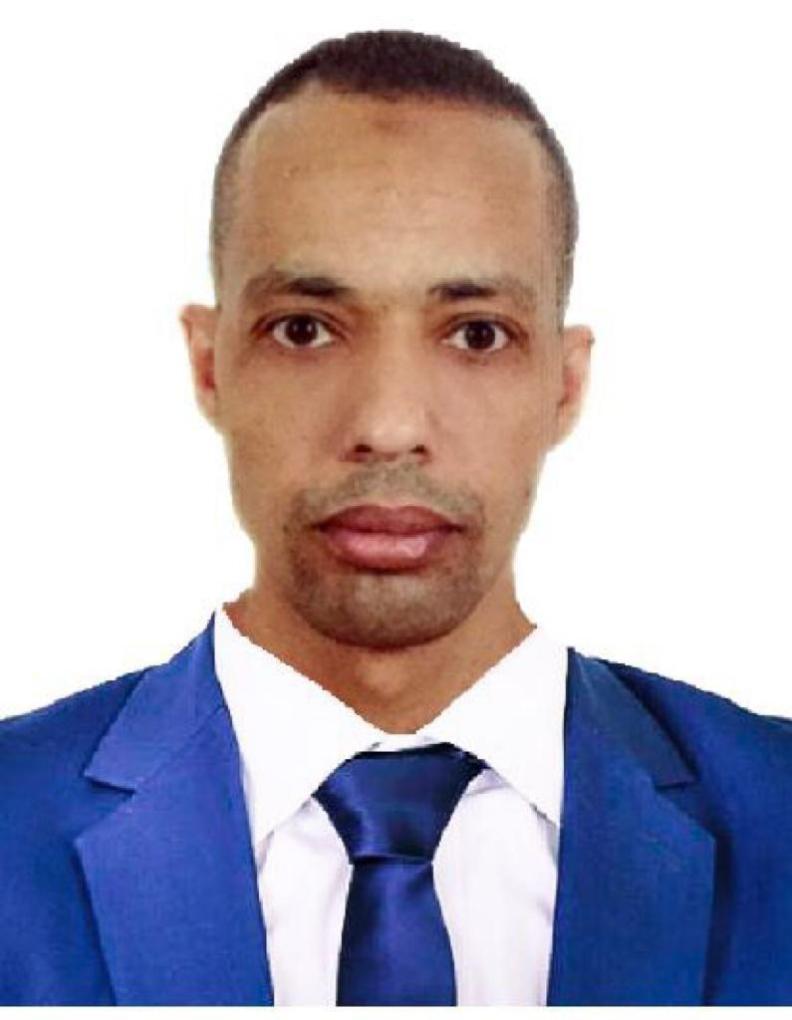
Address: Dubai, UAE
Email: abbas-394781@2freemail.com
Gender: Male
D.O.B: 08/11/1985
Nationality: Egyptian
Marital Status: Married

OBJECTIVE:
Seeking a challenge career in a company utilize my education and to acquire my career aspirations and where my interpersonal skills could be recognized, applied and developed where I can use my talents to grow and expand the company.
EDUCATION:
Diploma of industrial.

WORK EXPERIENCE:
In a Hotel, From December 2017 till October 2018 as F&B supervisor.
UAE. Emirates Fast Food (Sep 15, 2012 Till October 2017.
5 Years working experience
Egypt (Nov 05, 2007 To Sep 04, 2012) As Crew to Crew Trainer 4 years working experience.

Job Responsibility as Crew:
- Greets guests and presents them with the menu.
- Informs guests about the special items for the day and menu changes if any.
- Suggest food and beverages to the guest and also try to upsell.
- Performing basic cleaning tasks as needed or directed by supervisor.
- Filling in for absent staff as needed
- Communicate to the guest and provide assistance with their queries.
- Server food and beverage to the guest as per the course of order.
- Observes guests and ensure their satisfaction with the food and service.
- Promptly respond to guest with any additional request

Job Responsibility as Store Manager:
- Strong leadership of handling more than 40 employees in the branch.
- Preparing shift scheduling to all staff.
- Preparing Performance review and wage review to all staff monthly basis.
- Monthly sit down with all staff to know their concern.
- Managing branch inventory management to control the usage of products.
- Managing the P&L in the branch for achieving the highest profit in the branch.
- Preparing and project sales plans yearly.
- Maintaining the highest food safety in the branch.
- Handling Training of all staff to develop them.
- Managing the product ordering in the branch.
- Maintaining safety and security of the staff.
Job Responsibility as F&B supervisor:
- Responsible for all of the business operations of a dining establishment.
- Interviewing, hiring, training, scheduling and managing employees.
- Overseeing inventory, including food and beverage, supplies and other restaurant equipment.
- Resolving customer complaints regarding food quality and service and making sure the business complies with health and food safety regulation.
- Perform administrative tasks such as managing payroll and writing budgets.
Professional training and achievements:
- Dubai Municipality Food safety class certificate of (PIC: Person in Charge).
- Al Serkal Group Class certificate.
- McDonald’s Diploma certificate of (RLP: Restaurant Leadership Practice).
- McDonald’s Diploma certificate (BLP: Business Leadership Practice).
- McDonald’s Certificate class of (Standard of Business Conduct) .
- McDonald’s Certificate Class (McDonald’s Culture Activation) .
- Best Assistant manager in McDonalds UAE.
Information technology and personal skills:
- Over 12 years of experience in customer service and hospitality.
- Microsoft windows and Microsoft office (Outlook, Word, Excel and PowerPoint).
- Ability to multi-task while maintaining a positive attitude.
- Proving ability to listen and respond to demanding guest needs and problem solving.
- Full aware of safety and emergency procedure.
Languages:
- Arabic (Native)
- English (Excellent)

