Curriculum Vitae
Waleed

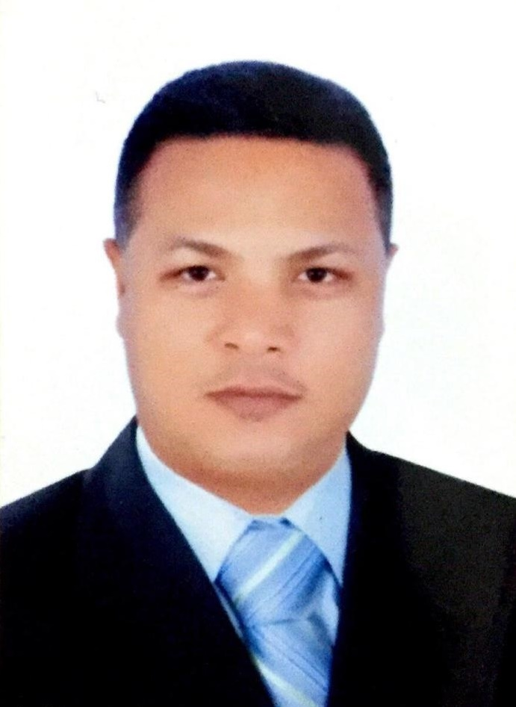
Email: waleed-394783@2freemail.com
Nationality: Egyptian
Address: Salah Addin, Dubai
DOB: 01/04/1985

Marital status: Married
Visa status: Employment visa

Career Objective:
Seeking a challenge career in a company utilize my education and to acquire my career aspirations and where my interpersonal skills could be recognized, applied and developed where I can use my talents to grow and expand the company.
Educational Qualification:
- Bachelor of agriculture in Egypt.
- Hotel management & Tourism
SKILLS:
- Strong Time Planning skills. - Good Understand Requirements.
- Problems solving.- Confidently Handle work Responsibility
- Good behavior and polite attitude. - Loyalty work and honest, trustworthy.
- Able to work under pressure. - Strong organization skills -Negotiation.
- Objection Handling.-Risk Management. -communication skills.

Language:
Arabic (Native)
English (Excellent)

Work Experience in Dubai:
- Supervisor in Carliton Palace Hotel from Jan 2019 till Oct. 2019.
- Supervisor Feb 2018 till July 2018.
- Supervisor in a Restaurant at Bur Dubai, UAE from May 2016 till Nov. 2017

Work Experience in Egypt:
- Restaurant Manager in a Hotel, Hurghada from 2013 till 2016.
- Head waiter Hurghada from 2007 till 2013.
- Captain at Sharm Alshaikh from 2005 till 2007.
- Captain at Sharm Alshaikh from June 2004 till May 2006.
- Assistant captain, Hurghada from March 2001 till April 2003.
- Waiter in a Beach, Hurghada from June 1999 till April 2001.

Computer skills:
- Microsoft Office ( Word, PowerPoint, Internet, Outlook)

Certifications:
- Hospitality Department Training.
- Food & Beverage Skills Development.
- Conflict Resolution the work place (Hilton Hurghada Plaza).
- Focus on Quality Complaint Handling.
- Leadership @ Hilton Hurghada Plaza.

