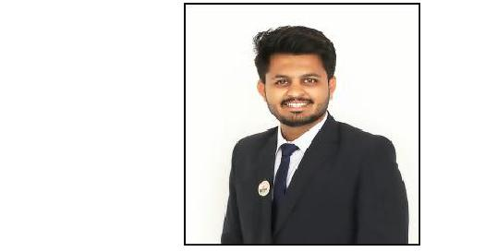
RAHUL

E-mail: rahul-394811@2freemail.com

Career Objective:

Seeking a competitive and challenging environment where I can serve my organization and establish a carrier For myself. To know something new and enhance my skills in a dynamic and stable workplace.

Work Experience:

Total Experience (09 Months)
  - Floor Coordinator. (Internship)

Hospital & Research Centre in PUNE.

- Facility orientation

- Overall responsibility of floor inventory.

- Monitor Housekeeping services. Duration:- 03 Months.

  - Floor Coordinator. (Internship)
HOSPITAL in PUNE.

For NABH Audit

- Facility orientation and patient education & Communication.

- Interdepartmental Coordination & Communication.

- Overall responsibility of floor inventory.

- Monitor Housekeeping services.

Duration:- 03 Months.

  - Management Trainee (Internship).

CLINI in PUNE.

  - Project Details: - To study the compliance rate to hospital referral policy.
Departments: - (Quality Assurance & Quality Control).
- Project Details: - Medical Record Files Auditing.
Departments: - Medical Record Department.
Duration:- 03 Months.

Academic Qualifications:

- Master’s in business administration (Healthcare Management) from Motion Institute of Management Studies, Jalgaon. 2018-2020.

Status- Pursuing Last Year

- Post Graduate Program in Healthcare Management (PGPHM) from Motion Institute of Management Studies, Jalgaon. 2018-2019.

Status- Completed (61%)

- Network Certified Engineer (NCE) From Institute of advance network technology (IANT) Panchavati Nashik . 2017-2018

Status-Completed (61%)
- Bachelor’s of Science (Microbiology) From P.O.Nahata College, Bhusawal.2014-2017.
Status- Completed (57%)

Academic Project Work:

- Project Details: -“Isolation of oil degradation bacteria from soil sample and biodegradation of petroleum and crude oil by Pseudomonas sp.”

- Project Details: - To study the compliance rate to hospital referral policy.
Departments: - Operation Management, QA, QC (Quality Assurance & Quality Control).
- Project Details: -Medical Record Files Auditing.
Departments: - Medical Record Department.
Duration: - 03 Months.

Summary of Skills:

Team Work | Agile Learning | Adaptability
Goal Oriented | Communication skills | Leadership Skills

Technical Skills:

- Networking
- Hardware

- Microbiological skills
- CSCU (Certified secure computer user)
- CCNA (Cisco Certified Network Associate)
- MS-Office
- MS-Excel

Certifications and Accolades:

- Certification of Certified secure computer user

- Certificate of participation of Global Sustainable Biotech Congress

- Certificate of participation of A⁺ (Hardware)

- Certificate of participation of N⁺ (Networking)

- Certificate of NCE (Network Certified Engineer)

Personal Details:

Nationality | : India
Date of Birth | : 20 November 1995
Marital Status | : Single
Language | : English, Hindi, Marathi

Mr. RAHUL

