RESUME
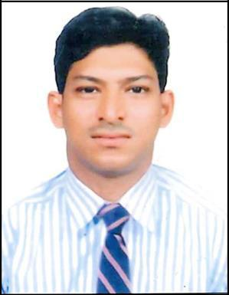

ABDUL

E mail: abdul-394842@2freemail.com

Dubai, UAE

PERSONAL DETAILS:
Name | : | ABDUL
Nationality | : | Indian
Marital Status | : | Married
Date of Birth | : | 20/04/1978
Visa Status | : | Employment Visa

----------------------------------------------------------------------------------------------------------------

OBJECTIVES:

To pursue a career in an organization having a global vision, which encourages creativity and offers an opportunity to learn and develop both in professional and personal aspects. I look forward to a career that would realize my own capacity, capability, experience and give me a satisfaction having of fully realized my potentials

MAJOR STRENGTH:

- Excellent presentation communication skills, both written and verbal

- Highly self motivated and strong interpersonal individual

- fast learner, hard worker and result oriented

- Ability to meet deadlines in an effective way

- Able to develop and implement policies and procedures

- Proven ability to lead successful programs and teams

- Ready to learn anything new in the shortest period possible

EDUCATIONAL QUALIFICATION:

- 11 P.U.C Badria P.U College Mangalore

- S.S.L.C ST. Josephs High School Mangalore

WORK EXPERIENCE:

- Presently Working as a Cashier in DUBAI from 1st DEC 2017 onwards

- Worked as a Tour Consultant in Dubai from July 2013 to August 2014

- 1 Year Experience as a Supervisor in SAUDI ARABIA From December 2015 to December 2016

- 1 Year Experience as a Tour Consultancy

- 3 Years' Experience as a Office Assistant

- 3 Years' Experience as a Assistance Supervisor IN ABUDHABI
- 1 Year Experience as a Office Assistant in MANGALORE

- 3 Years' experience as a Office Assistant in MANGALORE

- 3 Years' experience as a Tour Consultant in Travels Mangalore

Designation: Tour Consultant
- Communicating with travel partner to manage hotel booking and other services.

- Establishing and developing good relationship with and business partners.

- Make professional, accurate cost effective arrangement for client while providing excellent customer service.

- Responsible for answering all phone all from members travelling or needing information to any destination and booking such reservations in timely and efficient manner
- Answer phones professionally, courteously and promptly.

- Proactively market, sell and consult with client in regards to tour, cruise, visa air, car and hotel products and all other related services.

- Keep up to date with knowledge of vacation, tour , and cruise areas, tour packing, preferred enders and in- house groups.
- Manage several successful relationships with agents.

- Generation sales and giving high profit business to the company.

PERSONAL SKILLS:

- Good negotiation skills.

- Leadership, command and control skills.

- Problem solving and motivational skills.

- Ability to work under pressure & independently.

- Flexible mature to deal with dynamic situations.

- Excellent communication skills, Confident & Hard working.

- Quick Learner & cooperative nature.

LANGUAGES KNOWN:
- English .Hindi, Urdu, Kannada.

DECLARATION:

I do here by declare that the above mentioned information are true and correct to the best of my knowledge and belief

ABDUL

