CURRICULUM VITAE

NOORUL
DUBAI.
Email – noorul-394863@2freemail.com

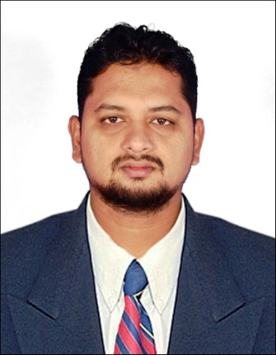
LOOKING FOR ASSISTANT ACCOUNTANT

Career Objective :
Seeking a position in your organization where my experience and Interaction skill
can be effectively utilized and can contribute in positive ways.
Professional Experience (Total Two year one months in India experience)
Company Name Hero bike company
Designation General Accountant
Working Period Aug 2017 to Aug 2019
Responsibilities :
- Making Every day PettycashReports in Excel sheet
- Making profit and loss Account Reports on weekly basis
- Making service and spare parts reports
- Making stock statement& inventory statement on daily basis
- Making Monthly staff salary reports
- Making monthly Gst prepare (Goods & service Tax) & Upload the reportsGST Websites
Professional Experience (Total one year & six months in India experience)
Company Name (Auditing Office)
Designation Data Entry (Tally ERP 9.0)
Working Period Aug 2015 to Jan 2017
Responsibilities :
    - Making purchase and sales entry
    - Making Bank statement entry
    - Making Tax calculation purchase and sales in Excel sheet
    - Making GST Prepare and Submit the Govt GST website

Professional Experience (Total One and half years Gulf experience)
Company Name company at Qusais
Dubai
Designation Data Entry cum Assistant Accountant
Working Period Feb 2011 to Apr 2012
Responsibilities :
    - Attending calls
    - Pod Updation
    - Bill of entry (Import & Export ) Mirshall – II
    - International Manifesting & Despatch
    - Prepared in Despatching AWB
    - AWB Manifesting (International and Domestic
    - AWB collect money from couriers and submit the senior manager
    - Maintain pettycash handling and day to day accounts submit the senior

- Software Skill Accounts & Auditing:

- Tally ERP 9.0
- Monthly GSTPrepare and Uploadthe Govt GST website
- High Rise in MS Word,MS Excel,
- Adobe Photoshop (PS)

- Educational Qualification:
Bachelor of Business Administration (B.B.A) under Graduate from Khadir Mohideen
College Adirampattinam. University of Bharathidasan Trichy, from India.

- Personal Information:

- Sex : Male
- Date of Birth : 14 May 1986
- Marital Status : Married
- Religion : Muslims
- Nationality : Indian
- Visa Status : Visit visas(January 2020)
- Language Known : Tamil, English,Hindi, Arabic ,Malayalam
- Driving License : Indian Driving license(from 2007)

- Hobbies :

- Travelling, Football, Reading Books

- Competencies :

- Organized well structures at wok,
- Commited to deadlines schedules
- Good team player
- Independent self motivated
- Good written communication skills
- Typing speed 40 wpm

- Reference :

- Provide as per request

- Declaration:

I hereby declare that the above information provided by me is true and correct
to the best of my knowledge and belief.

Signature
(NOORUL)

