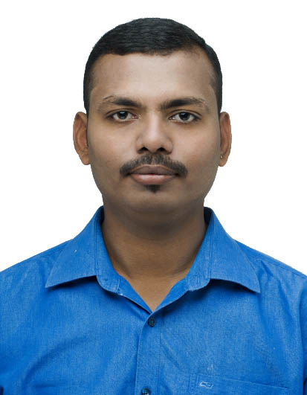

Career Objective _______________________________________________________________

To obtain a challenging and rewarding position that provides ample opportunity to learn and to contribute by utilizing my skills and abilities for the organization that offers me a room for professional growth while being ingenious, innovative and flexible.

Academic Qualifications_________________________________________________

Exam Passed | Year of Passing | Institute/ University | Class Obtained
Diploma in electronics &  communication | November 2014 | Dr T M A Pai Polytechnic,Manipal | Second class (58.95%)
SSLC(10th) | March 2007 | Viveka English Medium high school | Second class  (56.32%)

Area of Expertise_______________________________________________________________

- Trouble Shooting
- Preventive Maintenance
- Improving efficiency
- Material management
- Microsoft Office
Work Experience_______________________________________________________________

Dubai (October 2018 to Till date)

Roles and Responsibilities: Service Engineer
- Installation, Preventive maintenance & Break down Service of Silo placer unit
- Demonstration Preventive maintenance & Break down Service of Plaster machine
- Conducting appropriate training for customer employees on the equipment best practices
- Maintaining records of individual machine , preparing Daily reports
- Ordering and maintaining spare parts and equipment in Stock
- Preparation of Maintenance Plan and Implementation of the Same.
- Trouble shooting of Machine Related Problems.

Dubai (April 2015 to March 2018)

Roles and Responsibilities: Service technician
- Read blueprints or technical diagrams of PCB for trouble shooting.
- Understand the customer problems based on the detailed oral communication.
- Identify electrical problems of heavy vehicles with a variety of testing devices
- Estimating the general amount of time and material to complete service tasks.
- Perform business management duties such as maintaining records and files, preparing reports and ordering supplies and equipment.
- Install and maintain customized wiring and lighting systems of the heavy vehicles.
- Training the customer on the equipment best practices on usage.
- Pre delivery inspection before delivering to the customer.

Bangalore (May 2011 to Nov 2014)

Roles and Responsibilities: Sales & Service Engineer.
- Worked on Samsung Ultrasound machine .
- Worked on Mindray Patient monitoring system.

Projects worked______________________________________________________________

- Involved in constructing “Liebherr batching plant” for Conmix LTD.
- Involved in building the “ATLAS crane”.

serviced machine____________________________________________________________

- Caterpillar
- Putzmeister
- Reed
- Sika
- Dynajet

Trainings_______________________________________________________________________

- Bio medical Instruments at Mindray,Delhi.
- Jewellery manufacturing at MIJM,Manipal.

Achievements/Awards_________________________________________________________

- Participated in project festival at MIT Kundapura and won first prize for my project “LPG CUM SMOKE DETECTOR”.

Personal Details________________________________________________________________

Date of birth : 12/04/1991
Nationality : Indian
VISA status : UAE employment visa.
Driving License : UAE & India
Languages known : English, Hindi, Kannada,Tulu.

I hereby declare, that the above information and details provided by me are correct to the best of my knowledge.
Date: Yours Faithfully
Place:
( Ranjith)

