Vinay 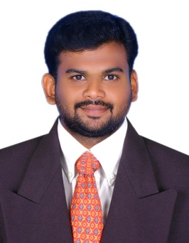
EMAIL: vinay-394908@2freemail.com

Professional Experience
Company  General Contracting, Abudhabi,United Arab Emirates(March 2018 – November 2019) | Designation  Civil Site Engineer | Site/Key Responsibilities  Site execution, preparing daily progress report, reinforcement checking as per bar bending schedule, Coordination with architect consultant , checking and supervision of finishing works, evaluation of Sub Contractor bill quality control and quality assurance, scheduling of works, checking and approving material used for the project, and completing the project.
Tamilnadu,India  (June 2014 – February2018) | Civil Site Engineer | - AV Builders, Neelankarai(G+4 apartment) Chennai.  - Harini Homes (G+2 villa)Madampakkam, Chennai.  - Ramgopal Enclave,(G+3) Mudichur,  - Chennai.  - SanskritiBlossoms,(Bungalow),Chennai.  My major responsibilities include project execution, planning, scheduling, supervision, quantity estimation, billing, monthly reports and work order preparation, checking and certifying contractor’s bills, coordination with the various Architects and Consultants and supervision of construction work.
Tamilnadu,India  (June 2012 – May 2014) | Site Engineer (Full time) | - SLK Homes at Thoraipakkam, Chennai.  - Vanith Raj Homes at Perungudi, Chennai.  - Rangarajan Enclave at Hasthinapuram, Chennai.  The major responsibilities included monitoring of site activities to ensure timely execution, preparing daily progress report, inventory & quality survey supervision of work, reinforcement checking as per bar bending schedule, Coordination with architect consultant , checking and supervision of finishing works, evaluation of Sub Contractor bill quality control and quality assurance, scheduling of works, checking and approving material used for the project, measurement of completed works etc.

Software Skills
SOFTWARE | : | PROFICIENCY
Auto Cad | : | Excellent
MS Office | : | Excellent

Educational Qualifications
B.E –Civil Engineering | : | RVS College of Engineering & Technology, Tamilnadu, India. | 74.8%
HSC | : | M.D.T Higher Secondary School, Tirunelveli. | 71.2%
SSC | : | M.D.T Higher Secondary School, Tirunelveli. | 69.2%

Personal detail
Date of Birth | : | 11th November 1990
Nationality | : | Indian
Linguistic proficiency | : | English, Hindi& Tamil
Professional Experience | : | 07 years & 6 months (full time)
UAE Driving license | : | YES

_________________________________________________________________________________________________________
Certification
I, the undersigned, certify that to the best of my knowledge and belief, these data correctly describe my qualifications, my experience, and me.

(vinay)

