Mr. HARIS

Haris-394923@2freemail.com

Dubai, UAE

PERSONAL DETAILS

Name: Mr. Haris

Nationality: Indian

LANGUAGES KNOWN

- Fluent in Arabic and English (both writing and speaking)

- Hindi

QUALIFICATION
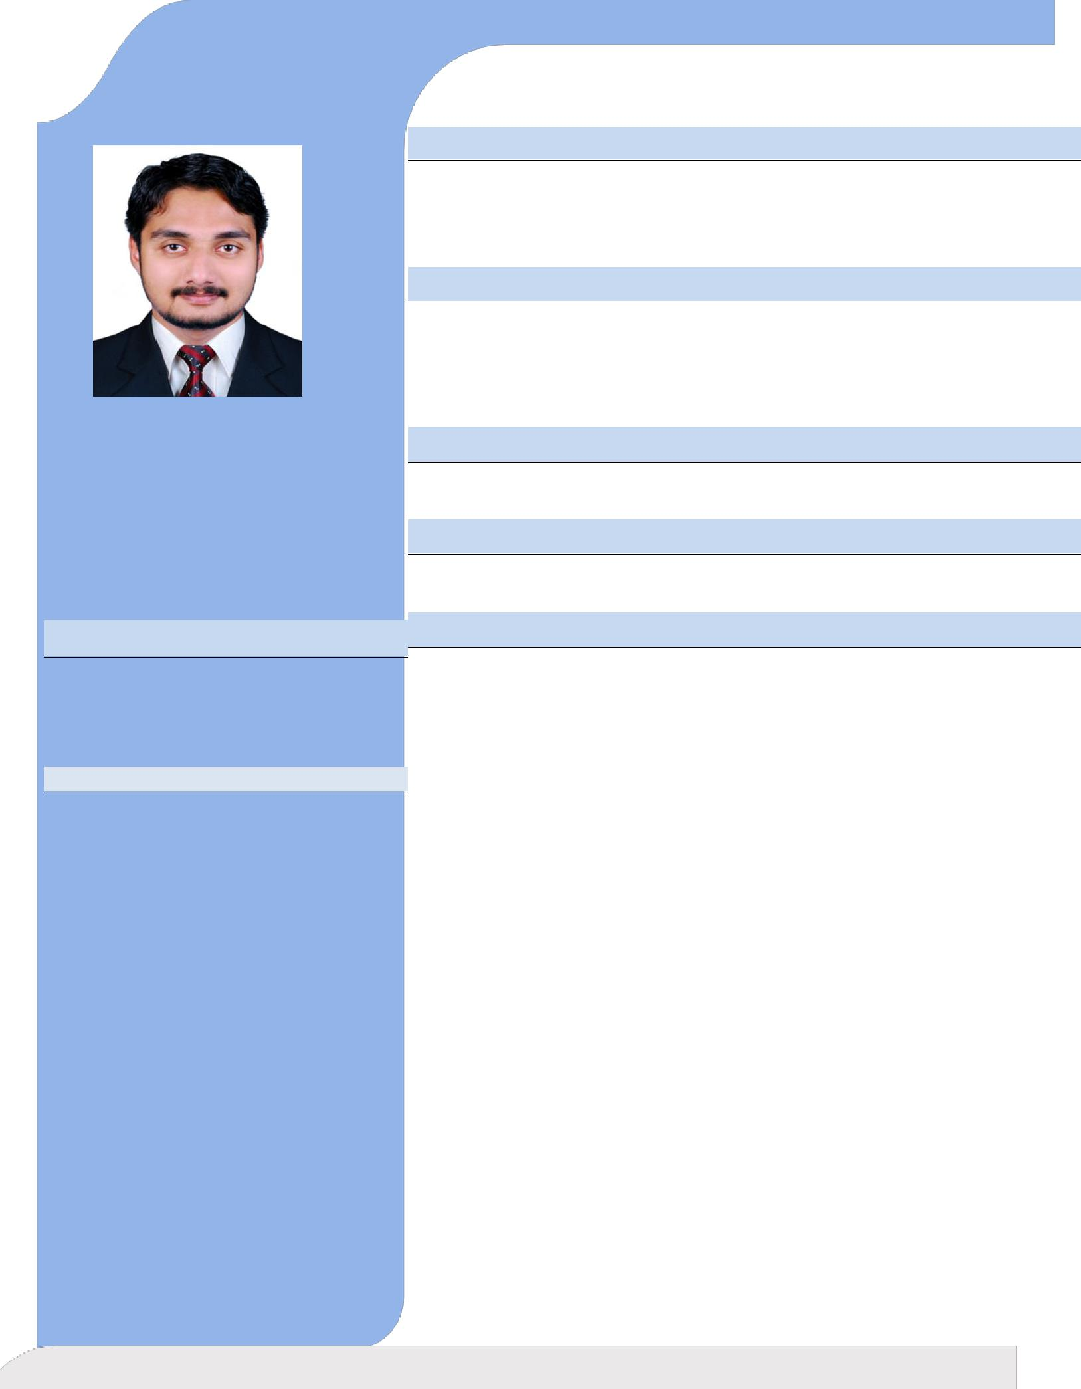

BSc NURSING (Calicut University, India)
HOSPITAL in KERALA,INDIA
(450 BEDDED HOSPITAL)
PROFFESSIONAL LICENCE AND REGISTRATION

DHA- RN

Registered Nurse & Registered Midwife [RN/RM]
(REG in INDIA)

EXPERIENCE AND SPECIALIY

OPERATION ROOM (5+ YRS)

ADDITIONAL QUALIFICATION

ACLS AND BLS

HOSPITAL INFORMATION

Hospital

Hospital in Kerala,India, is a 450 Bedded multi super specialty referral hospital started in 1990 with all specialties and Seven super specialty departments. The hospital is equipped with 12 operation theatres and 9 ICU units. This is the first and only hospital in our district doing Renal Transplant & Cardio Thoracic Surgery. The hospital has got full-fledged heart care centre. Moulana Heart Foundation with fully Flat Panel Cath Lab and Cardio Vascular Surgery. This hospital also having several super specialty wings like Neurology, Neurosurgery, Orthopedic, Level 3 Trauma care, Urology, Neonatology, Nephrology with dialysis unit, Renal transplantation unit, IVF specialty, General

Surgery with Hernia clinic, Ophthalmology, Gastroenterology Obstetrics and Gynecology, ENT, Plastic surgery, Pulmonology, OFMS, Endocrinology, Diabetology, Oncology…etc

EMPLOYMENT HISTORY

- Staff Nurse, Hospital in India (2018 December to 2019 October)

- Staff, Hospital in India
(2016 May to 2018 June

- Staff Nurse, Hospital in Kerala,India (2014 September to 2016 April)

- Staff Nurse, Hospital in India (2011 November to 2014 August)

PRACTICAL EXPERIENCE

- All Minor Major ENT Surgeries

- Endoscopic Tympanoplasty

- Endoscopic Septoplasty

- FESS, Mastoidectomy

- Coblation Adenoidectomy

- Coblation Tonsilectomy

- Micro Laryngesl Surgery

- Polipectomy

- Foreign body Removel

- Myringotomy

- Endoscopic Cautarisation

- Orthopedic Surgeries

- General Surgeries

EQUIPMENTS HANDLED

  - Coblator, MicroDebrider, MicroDrill,C ARM,Diathermy

  - Mechanical Ventilators, Non-invacive Ventilators.

  - Cardiac Monitors, Ambu bags and intubations tray.

  - Defibrillator, Syringe pump, Infusion pump, Cardiac Monitors.

  - Nebulizer,Pulse Oxymeter, Centralized Suction, Microscope, ABG Machine.

DECLARATION

I hereby declare that the above given information is true to the best of my knowledge and belief and can be supported by relevant certificates and documents.

Haris

