HAFEEZUR 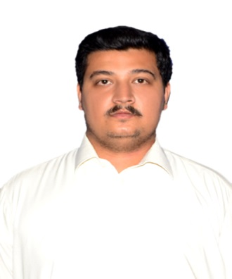
M-45
Musaffah, Abu Dhabi
Visa Status Employment
EMAIL: hafeez-394940@2freemail.com
OBJECTIVES
To get a challenging job which enables me to make use of my knowledge, I would like to work in a highly competitive environment, to achieve highest standard of quality and quantity of work for an organization with in available resources (men and material).
PERSONAL DATA
- Date of Birth 15 December,1992
- Religion Islam
- Marital Status Married
- With UAE Driving License
SKILLS
- Team work
- Written and verbal communication skills.
- Self-motivation and ability to take the initiative.
- Ability to work well under pressure.
Computer Skills
- MS Office
- Internet Browsing
- AutoCAD
- Machine Maintenance
Languages
- English Excellent (Speak, Read & Write)
- Urdu Excellent (Speak, Read & Write)
- Hindi Excellent (Speak, Read & Write)

Work Experience
- Safety Supervisor(since June 2018)
Company in Abu Dhabi
Responsibilities
Responsible for doing regular work site inspections and bringing any safety issues up to field management.
Responsible for filing regular local state and federal safety reports for each project.
Responsible for creating a monthly safety briefing for project managers and executives working out of the main office.
Responsible for quarterly safety audits for the local state and federal safety agencies.
Responsible for developing and updating all safety policies on all work sites.

- Assistant Safety officer for 1 year with Ghulam Rasool and Company, Swabi, KPK.
- HSE Supervisor for 4 Years with Govt. of KPK communication and Works Division, Swabi, KPK, Pakistan.

Education
- DIPLOMA from NEBOSH (IGC)
- OSHAD Practitioner
- F.Sc from Army Burnhall collage for boys Abbotabad.
- Matriculation from The Quaid-e-Azam public school Zaida(Swabi) KPK.
COURSES COMPLETED
- NEBOSH International General Certificate in Occupational Health and Safety
- IOSH Managing Safely Course from Institute of Occupational safetyand Health.
• AutoCAD Certification.
- Certificate in MS Office,Computer Hardware amd Typing(40 rpm).

