RIYA

•Email: riya-394966@2freemail.com

SEEKING ASSIGNMENTS AS TECHNICAL SUPPORT ENGINEER

EXECUTIVE SUMMARY
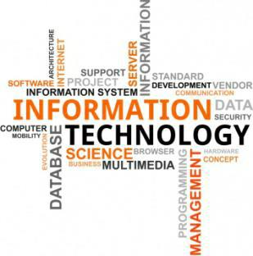

- Technical support engineer with 3 years of experience in technical support, Application support, Desktop Support and networking infrastructure.

- Focused, Result-oriented, Analytical skilled Professional with strong experience in administration, customization and implementation.

- Experienced in designing, deploying Applications and upgrading systems, including hardware, software, networks, databases, servers and peripheral equipment.

- Possess comprehensive experience in configuring, optimizing and troubleshooting of Windows, Linux servers and the Networking setups.

- Maintained and managed the 24*7 production environments of the multiple projects with high success.

Core Competencies:
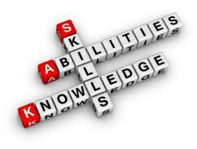
Application support • Desktop Administration • Service Now• MS Outlook • End User Documentation

- Project Management • Remote Support • Leadership Programs • Team Management

KEY PROJECT HIGHLIGHTS

Analyst (USA)
- Providing end to end resolution to the issues faced by the client.

- Diagnose, troubleshoot and resolve a range of software, hardware and connectivity issues.

- Partnered with Tier II and Tier III help desk peers based in the US and India to resolve complex problems that required escalation.

- Providing IT Support to the customers through the process of ITIL.
- Assisting with the Active Directory, Citrix Login & LDAP Credentials.

- Providing troubleshooting steps for Microsoft Outlook 2013 for connection issues and login issue for Skype for Business Advanced.

- Have a great knowledge about interaction with clients through calls, or through chats, or through the web-based tickets.
- Administration of Monitoring tools: SCOM, SOLARWINDS and SCIENCE LOGIC

- Responsible for all System Center Operations Manager (SCOM) applications and Infrastructure.
- Subject matter expert on Enterprise class monitoring systems including System Center Operations Manager.

- Designed and Implemented SCOM 2012 environment with multiple management groups monitoring over 10,000 servers and devices.

- Upgraded SCOM 2012 R2 to SCOM 2016 and provided maintenance for SCOM R2 Infrastructure.
- Implemented Unified dashboard solution using Squared up for System Center Operations Manager.

- Implemented and configured standard Microsoft Management Packs: Active Directory, SharePoint, Lync, Exchange, SCCM, IIS, SQL, Forefront and Windows Server.

- Implemented and configured 3rd party Management Packs

- Follow ITIL framework & practices - Incident, Problem and Change Management via Remedy and Service-Now IT Service Management Suite.

- Familiar with Active Directory (AD), DNS, WINS and DHCP.
- Familiar with Citrix XenApp and XenServer Monitoring and Basic Administration.
- Basic understanding of PowerShell, WMI and SQL Queries.
- Evaluate new and existing technologies and provide recommendations for monitoring and enhancements.
- Implemented improvement procedures on Microsoft SCOM based systems.
- Formulated custom reports via SQL server Reporting tools.

SOLARWINDS

- Audit existing SolarWinds implementation and suggest areas for improvement in addition to training and directing client personal in the configuration, management, and use of NPM, NTA, SAM, and WPM.

- Design Custom Properties solution to allow for more granular monitoring, alerting, and reporting.
- Design Groups and Dependencies to streamline monitoring and alerting.
- Configure standard SAM based monitoring in support of clients Linux based e-Commerce system.

- Develop custom SAM templates using PowerShell and SQL queries to implement monitoring of non-standard systems. Including 3rd party databases, internal and COTS based applications, and Windows based operating systems.

- To add and manage the network devices/data devices as per the client requirement.
- Review, update, and create network monitoring policies and procedural documentation.
- Manage SolarWinds NPM, WPM monitoring services and nodes.

SCIENCE LOGIC (EM7 Module)
- Addition and removal of the monitoring devices.
- Administration of devices.
- Monitoring of UNIX, LINUX and SQL/ Database devices.

TECHNICAL SKILLS

Operating Systems:
Mail Servers:
Ticketing tool:
Email Clients:
IT Certification:

Red Hat, Windows Server 2003, 2008, XP, 7
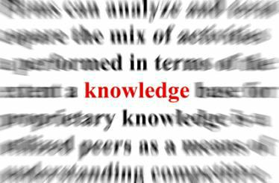
MS Exchange
Remedy, Service now
MS Outlook
ITIL, Incident Management

CAREER CONTOUR

Analyst

Jul 2016 – Aug 2019

Key Deliverables:
- Providing IT Support to the customers through the process of ITIL.
- Working within the defined SLA parameters to help efficiently the users regarding the issue.

- Assisting with the Active Directory, Citrix Login & LDAP Credentials.

- Providing troubleshooting steps for Microsoft Outlook 2013 for connection issues and login issue for Skype for Business Advanced.

- Working with the Knowledge Management team to provide the latest and the best ways to the clients to resolve the issues in more convenient way.

- Have a great knowledge about interaction with clients through calls, or through chats, or through the web-based tickets.

- Have a great knowledge about the other teams that work under the process of ITIL, I.e. Incident Management, Change Management and Problem Management etc.

- Creating tickets on Service Now for every interaction with the clients and help resolving the tickets.
- Working with in supporting Windows 2008, 2012 Server environment.
- Monitoring the Severity alerts/Tickets and working with the client till resolution.
- Triaging tickets to the proper queue with all information required to process ticket before reporting issue.
- Providing end to end resolution to the issues faced by the client.
- Providing user training, support and feedback.

ACADEMICS CREDENTIALS

Bachelor of Engineering in Electronics and Communication Engineering from CCET, Bhilai. 2012-2016 Hands on training in ITIL Infrastructure

Date of Birth:
References:

29th of August 1994
Available on Request

