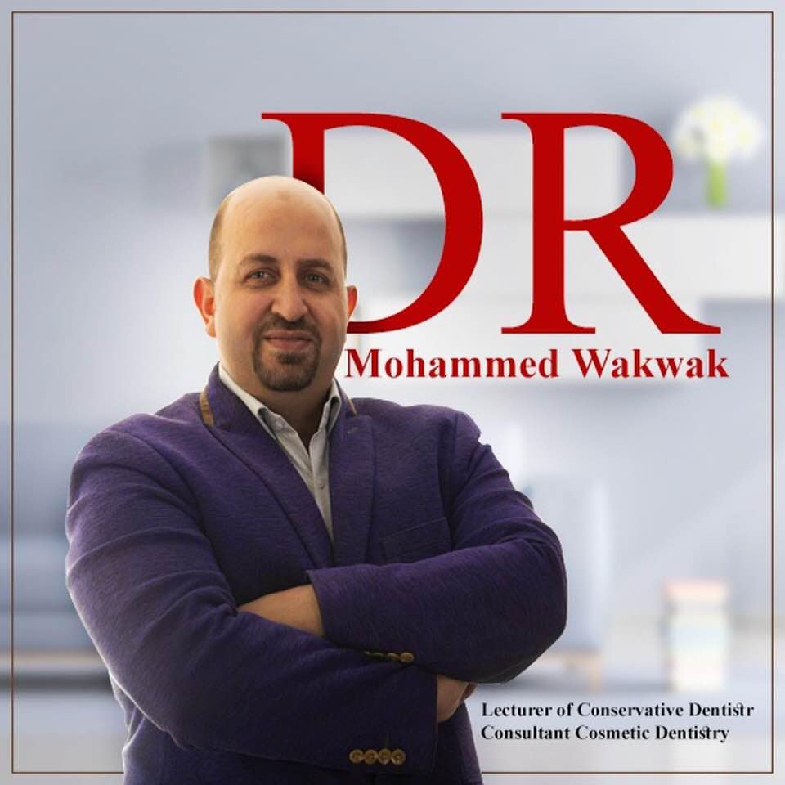 |  | Wakwak  Dentist
Profile  Consultant Dentist over 15 years experience; Expertise Dentist, Accomplished of Esthetic Dental Restorations, direct patient care (including examinations, evaluations, assessment and treatment of direct restorations, endodontics, post &core, full coverage crowns, CAD/CAM Ceramics and Indirect Restorations) and Achievement of full mouth rehabilitation.  Contact  EMAIL:  Wakwak-394984@2freemail.com  Hobbies  Running  Reading  Travelling  Swimming |  | EDUCATION  Faculty of Dental Medicine. Al-Azhar University:  9/1999-6/2004 BDS; Bachelor’s degree of Oral &Dental Medicine  7/2006- 6/2011MSc: Master’s degree of Operative Dentistry  2/2012–8/2016 PhD; Doctoral degree in Conservative Dentistry  WORK EXPERIENCE  Consultant Dentist  11/2010– 10/2019  CAD/CAM Ceramics and Indirect Restorations and Achievement of full mouth rehabilitation.  Specialist Dentist  8/2008– 11/2019  Skills and knowledge of clinical coverage in all aspects of general dentistry; Expertise Dentist, Accomplished of Esthetic Dental Restorations, direct patient care (including examinations, evaluations, assessment and treatment of direct restorations, endodontics, post &core, full coverage crowns  General Dentist  10/2005– 10/ 2019  Skills and knowledge of clinical coverage in all aspects of general dentistryAccomplished of Esthetic Dental Restorations  SKILLS

