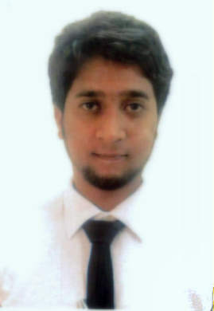
Mohsin

Email: mohsin-394995@2freemail.com
Visa Status : Work Permit

CAREEROBJECTIVE:

I would like to pursue a challenging career and strive hard to acquire knowledge and achieve higher grounds in the ever growing and innovative field of Networking. My areas of expertise include
Network & System Administration, NOC Administration and onsite technical support involving software and hardware

CAREER PROFILE/SKILLS:

- Helpdesk/Technical Support
- Data Recovery

PROFESSIONAL WORK EXPERIENCE:

Organization:
(Construction Company in Dubai)
Tenure: 19–May-2015 till Present
Designation: IT Support Engineer

Responsibilities:

- Administering, configuring and troubleshooting of Windows 2012/2008 Server.
- Dealing with hardware and application support queries and issues reported to the support desk and escalated to the Desktop Support Administrator
- troubleshooting system and network problems and diagnosing and solving hardware or
software faults.
- Thorough understanding and experience of TCP/IP based networks.
- Installation of CCTV IP camera.
- Installation printers through network.
- Installation, Configuration all Printers.
- Managing Data Backups and Restores
- Installing and configuring computer hardware operating systems and applications.
- Monitoring and maintaining computer systems and networks.
- talking staff or clients through a series of actions, either face-to- face or over the telephone, to
help set up systems or resolve issues.
- Working continuously on a task until completion (or referral to third parties, if appropriate
- Installation of Biometric machine.
- Bitdefender gravity zone Server, handling bitdefender gravity zone control console.
- Managing all routers and wireless router.
- Setting up new usersaccounts and profiles and dealing with password issues.

Organization: in Hyderabad, India

Tenure: January 2013 to September2014
Designation: System Engineer

Responsibilities:

  - Duties involved managing and maintaining the Workgroup of the company, maintaining the hardware,
and supporting end users day to day activity.

ACADEMIC EDUCATION:

DEGREE/CERTIFICATION | EXAMINING BODY: | YEAR
Bachelor of Computer Science | Osmania University | 2013

CERTIFICATION/ ADDITIONAL SKILLS:

- MCITP 2008 Server

PERSONAL INFORMATION:
Date of Birth : 9-June-1991
Driving License : UAE

