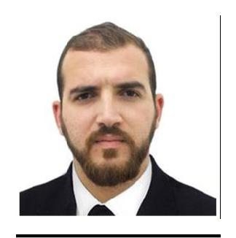
Mechanical Engineer (Mechanical Fabrication)

Nam: Anis
Age: 29 years old.

Status: Married.

E-mail: anis-394998@2freemail.com

SUMMARY:

A self-starting, highly motivated, able to work alone or as part of team. Strengths include high work standards, logical and planned approach to project work, the ability to make rational judgments and sharing good practice. Fast learner, relish a challenge and willing to train extensively for a position.

Good communication skills. Good command of spoken and written English, French and Arabic.

Willing-ness to learn new skills and take on responsibility.

EDUCATION:

2009 | BSC in Civil engineering
Annaba - Algeria 18 February technical high school Bouzaroura
2015 | Bachelors degree in mechanical engineering (mechanical
productivity)
Annaba - Algeria University of Badji Mokhtar Sidi Amar
2016 | Master I in mechanical engineering (mechanical
productivity)
Annaba - Algeria University of Badji Mokhtar Sidi Amar
Languages: | Arabic: speakin, reading and writing | Native
 | French: speakin, reading and writing | Average
 | English: speakin, reading and writing | Average

Controlled software: Word, Excel, Solidworks, Catia, Autodesk Fusion 360,

Autocad
Blender.

TRAINEESHIP :

March/2015 Training certificate

COMPANY: I-Metal Hadjar, Unity ATCx (Central workshops)
Annaba, Algeria technical office
Acquired skills from this training period:

- Apply the theoretical gains.
- Take a closer look at machines.

- Benefit from experiences on the level of preparation and production.

WORK EXPERIENCE:

March/2016 – March/2018 (02 years)

Annaba, Algeria

Occupation: Preparation engineer

Missions and tasks:

-Study of technical plans and creation of machining range.
-Technical drawing.
-Programmed the numerically controlled machines (code G).

-Folow-up the machining with the workshop leaders.

COMPANY:

Annaba, Algeria

I-Metal Hadjar, Unity AMM (The

Occupation: Zone engineer (HFx, PMA).

Missions and tasks:

-Study and analysis of work demand received by HF unity (unity of Blast Furnace) and the PMA unity (unity of raw and agglomerated material preparation),

-Preliminary study of purchasing demand received by the HF and PMA units,
-Preparation of income reports.
-Workshop machinig programing.

-Schedule meetings with heads of services and technical offices
managers of other units to improve the exchange of sevices between the units.

-Contact other companies to create income opportunities.

SKILLS:

- Project management.
- Strong decision maker.

- Complex solver.
- Proactive problem solver and analytical thinker.

- Service-focused.

HOBBIES:

Portraits drawing, caricature, 3D animation, sport, reading, travel.

