CURRICULUM- VITAE
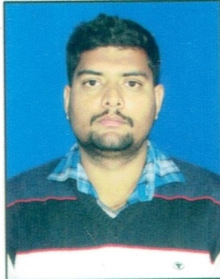
SUNIL
Email: sunil-395001@2freemail.com

Objective | Seeking a challenging career with a progressive organization which will utilize my skills and abilities in the Industry that offers professional growth while being resourceful, innovative, and flexible and ability to learn new things every day.
Education &Competence | Academic & technical Qualification  - Bachelor of Arts, Punjab university, completed in 2011  - Fire marshal/warden training, Enertech Qatar.  Skills  - Integrity  - Teamwork  - Good Communication & Interpersonal Skills  - Strong interpersonal skills.  - Honest and sincere about responsibilities, always aspiring to fulfill targets and schedules  - Positive attitude; achieve results through smart work and dedication  - Manpower and Equipment Management.  - Operating System: Microsoft.  - Tools and Packages: MS Office
Work Experience  Job Profile | - Presently working as welfare assistant in Qatar since December 2016.  - Worked as welfare assistant in Qatar from December 2015 to November 2016.  Roles and Responsibilities:-  - Responsible for full fill all Statutory Compliances under various acts.  - Handling Security Personnel, transport & housekeeping.  - Maintaining office & guest house equipment.  - Monitoring plantation and day to day administrative requirements.  - Maintenance of dining halls, rest areas and other welfare facilities.  - Handling of food supplies to the workers.  - Maintain the notice board with the information about “Thought of the Day” message, Employee of the month announcement, articles on weekly and fortnightly basis.  - Maintain all HR files and employee information in various forms like employee database, employee CV's, review history, preparing all HR letters and certificates. etc.  - Regular maintenance of workers and staff accommodation.  - Introducing Suggestion Scheme for Employees.  - Celebrating Birthday of the Employees.  - If the new joiners is been recruited with reference of the company Staff, disburse the amount as per Buddy Scheme.  - Conduct Sports Day for Employees and their Children in the month of December.  - Conduct Safety Day and Safety Week.
Personal Details | Date of Birth : 08-09-1990  Nationality : INDIAN  Marital status : Married  Languages Known: English, Hindi, & Punjabi.
Declaration - I hereby declare that all the information’s furnished above are true to the best of my knowledge and belief.

SUNIL
Place : Doha

