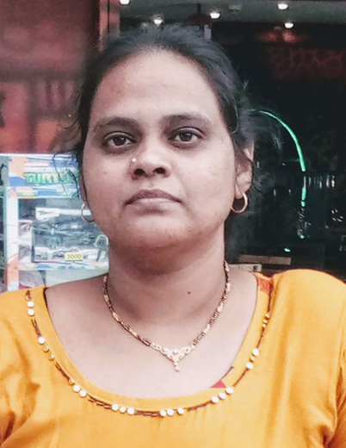
CURRICULUM VITAE
- ARUNA
Contact NO: 0552861878
Email:arunalucky28@gmail.com
Sharjah dubai,uae

Personal Profile
- Gender : Female
- Marital status : Married
- Languages : English,Hindi,Telugu
- Visa Status : Visit Visa
- Nationality : Indian
- Date of Birth :19-07-1982
Career Objective

To be part of the company that indulges professional growth which provides challenging and rewarding career while following me to utilize knowledge and skills.
Educational Qualificatio
- Diploma in Civil
- S.S.C

Professional Experience

- Autocad Drawings {Gis} in Infotech Enterprises PVT LTD.Hyderabad, Telangana.
Durtion :5+years

Responsibilities
- Developed complex project design specifications.
- Provided multiple project design support.
- Guided and mentored junior staff members as required.
- Handled both large and small-scaled drafting projects.
- Developed efficient designs in collaboration with CAD operators.
Skills and Strengths

- Disciplined and well mannered with good sense of ethics
- Flexible and can be able to work in a multicultural environment
- Good communication skills
- Ability to work under pressure for long hours
- Good Observation, alert and vigilant
- Pleasant personality, character and attitude
- Seek first to understand and then to be understood later

References:
Can be provided up on request

Declaration
I declare that the information provided above is true and correct to the best of my knowledge.

