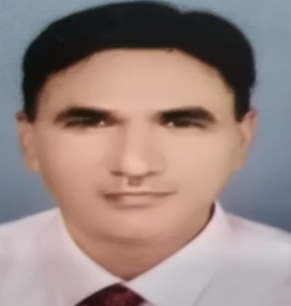
NAKIUR
Email: nakiur-395031@2freemail.com
Visa Status Visit Visa

My Profile
Over 19 years of experience in Sales and Marketing department of Toyota, Riyadh (Saudi Arabia). I have relevant experience in handling global client. A dynamic professional with a blend of assertiveness, good communication skills, creativity, analytical ability, risk taking ability, interpersonal sensitivity, perseverance, presentation skills, decision making ability and a professional attitude.

Work Experience
- Supervisor, Parts Division in Riyadh (Jan 2008 – Nov 2018)
- Service Controller, Parts Division in Riyadh (Jan 2004 – Dec 2007)
- Sales Executive, Counter Sales, Parts Division Dealer in Riyadh (Aug 1999 – Dec 2003)
Job Responsibilities
- Business Development:Generating initial purchase orders of new model vehicle parts. Creating orders for all vehicles part for new and fast moving item. Controlling non-moving items to maintain and streamline organization’s efficiency. Training sales person (counter & outdoor) with the technical aspects of the vehicle. Presentation of new vehicles catalogue including accessories. Proper ordering of parts including seasonal requirement. Monitoring the records of branch transaction. Maintaining good customer relationship. Taking care of after sales support through a team of professionals.
- Inter Team Collaboration:Hold periodic meetings of sales manager and other departments. Advisor to the senior managersoncomplex problemsarising out of complaints raised by the customers. Instructing personnel at various levels on proper handling and operations of new vehicles.
- Brand Development:Assisting senior managers in branding campaigns. Minimizing customer complaints to help improve the image of the organization. Settle customer complaints immediately. Directly involved in the conversation and implementation of all operations throughout the organization.

- Office Administration:Reporting important aspects of the business within strict deadlines. Processing of supplier invoices quickly and efficiently. Review purchase order daily. Coordination between sales team and business executive. Analyzing and making reports on various specification details provided by Toyota cooperation. Receiving parts on a weekly basis against the orders placed and allocating the same to all branches. Maintaining database of all orders received. Generating stock report and presenting to management.

Technical Skills
- Diploma in Computer Science, LCC, Patna
- Proficient in MS Office applications (MS Word and MS Excel)
Academic Overview
- MBA (Marketing), from JRNV University, Rajasthan in the year 20011
- Bachelor of Arts from Magadh University, Bihar in the year 1991
- Intermediate of Science from Magadh university, Bihar in the year 1988
- High School from Bihar State Board in the year 1985

Passport Details
Validity June 2020
Issued from Riyadh K.S.A

Having Valid Driving Licence of KSA.

Languages Known : English, Hindi, Urdu, Arabic
(Read Write and speak)
I hereby declare that the above information is true according to my knowledge.

(Nakiur)

