CURICULAMVITAE
Jyoti  Email id: jyoti-395062@gulfjobseeker.com | 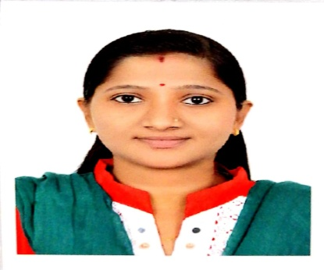

CAREER OBJECTIVE:
To seek challenging work environment in nursing which will nurture my talent nursing care and to upgrade my knowledge.
PERSONAL DETAILS:
Date of birth | : | 04th November 1993
Sex | : | Female
Religion | : | Hindu
Nationality | : | Indian
Marital Status | : | Married
Languages Known | : | English, Hindi Marathi & Telugu

EDUCATIONAL QUALIFICATION
S.No. | Exam | Year of Passing | Board / University
1 | RGNM (Revised General Nursing and Midwife) | 2017 | Board of Examination  Guru Nanak Hospital & Research Centre Mumbai
2 | 12th | 2012 | Maharashtra State Board Of Higher Secondary Examination
3 | SSC | 2010 | Maharashtra State Board of Higher Secondary Examination

SPECIAL QUALIFICATION
- BLS(Basic Life Support)
Certificate Number - FCD9D030167B
- Date Completed 02/06/2019

WORK EXPERIENCE
- Hospital & Research Centre in Mumbai
From 26/04/2017 to 09/09/2019
Unit: Operation Theatre

CASE EXPERIENCE:
- General surgery cases
- Gynac surgery cases
- Orthopedic surgery cases

PROCEDURES WE DO

- Suctioning ( Oral, Nasal, Tracheotomy, ET Tube)
- Cardiac Monitoring on Monitor
- Monitoring using Glasgow coma scale
- Ryle’s catheterization
- Foleys’ s Catheterization, Foleys Care
- Arterial Blood Gas Analysis
- Maintenance of Personal Hygiene
- Mouth Care
- Back Care
- Eye Care
- Sponging
- Bedding
- Taking and recording vital sings
- Central Venous pressure monitoring
- PA Pressure Monitoring
- ECG Monitoring
- Oxygen Administration
- Nasogastric Feeding
- Blood Sugar Monitoring
- Care of Equipment
- Maintaining Record and Reports
- Administrating Medication and Intravenous Fluids
- Oral Medication
- Blood Transfusion

EQUIPMENTS USED
- Monitors
- Cardiac Monitor
- Defibrillator
- Pulse Oxymeter
•Sphygmomanometer
•Thermometer
•Nebulizer
• Syringe Pump
•Ambu Bag
•Oxy Prong/Oxygen Mask
•Laryngoscope
•Glucometer
•Steam Inhaler
•Spirometer
•BYPAP
•Ventilator

DUTIES AND RESPONSIBILITIES
- Admission and discharge of day care patients
- Maintain personal hygiene and comfort patient
- Provide psychological support
- Attend the Nutritional needs of the patients
- Daily living activities
- Maintain clean and safe environment
- Coordinate patients care with various health members
- Follow doctor’s round
- Perform technical tasks
- Administration of medication
- Assisting doctors in various medical procedures
- Preparing articles and patients for medical or nursing procedures
- Recording vital signs
- Help doctors in diagnosis and treatment
- Maintain intake and output chart
- Observer change in patient condition and record
- Attending critically ill patients
- Rehabilitation

WARD MANAGEMENT
- Handover and takeover the patient and ward equipment and supply
- Keep the ward neat and tidy
- Maintain safety of the ward equipment
- Prepare and check ward supplies
- Assist ward superior in ward management
- Supervises other junior nursing personnel

DECLARATION
I do hereby confirm that the information given is true and correct to the best of my knowledge and belief.
Place - Dubai
(Jyoti)

