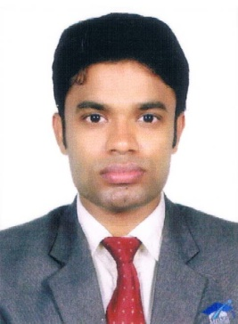
ABDUL
SPECIALISED IN HUMAN RESOURCE MANAGEMENT

Email : abdul-395063@2freemail.com

CAREER OBJECTIVE:
Seeking a suitable position in HR in a well reputed firm, Company or Organization.
ACADEMIC QUALIFICATION:

Qualification : MBA (HR&FINANACE)
Year of Completion : 2015- 2017
Institution : Monti International Institute of Management Studies, Perinthalmanna,
Kerala, India.(University of Calicut)

Qualification : B Com (Co-Operation)
Year of Completion : 2014
Institution : Co Operative Arts College Manjeri, Kerala, India.
Affiliated to University of Calicut, Kerala, India.

Qualification : Higher Secondary Education (Commerce)
Year of Completion : 2011
Institution : Govt Vocational HSS Makkaraparamba, Malappuram, Kerala

Qualification : SSLC
Year of Completion : 2009
Institution : Govt Vocational HSS Makkaraparamba, Malappuram, Kerala
Qualification : MA industrial psychology (distant under Ignoue University) 2018-20
WORK EXPERIENCE
- HOSPITAL ADMINISTRATOR

Edavanna ,Othayi .from 5thjune 2017 onwards

- HR EXECUTIVE

(Authorized dealer of Honda two wheelers), Angadippuram. From 25thjune 2014 to 14th august 2015.

FIELD OF INTEREST:
- HR Management
- Finance Management

COMPUTEREFFICIENCY:
- Application Softwares :
  - MS Office Excel, Word and PowerPoint

PERSONAL INFORMATION:

Date of Birth : 26-12-1993
Gender : Male
Marital Status : Single
Languages Known : Read Write & Speak - English and Malayalam
Read & Write - Hindi, Urdu and Arabic
Driving License details : Valid Indian Driving License (LMV& 2 wheeler) up to 2032.

PASSPORT DETAILS:
Country Code : IND
Date of Expiry : 21st November 2022

DECLARATION

I hereby declare that the information furnished above is true, correct and complete to the best of my knowledge.

Place :
Date : ABDUL

