Civil Engineer

Dubai UAE

Awad

Education

B.E in Civil Engineering

- Mansoura University, 2014

Project Management and Control Technique- Summer course

- Mansoura university, Cairo, 2014

Skills & Computer Literacy

- Revit

- MS Project

- AutoCAD

- MS Word, Excel, PowerPoint

- Robot

- Sketch up

- SAP 2000

- ETAPS

- English, Arabic: read, written, and spoken fluently.
- Urdu : spoken fluently

Nationality: Egyptian

Birth Date: 12-Mar-1992

Driver License: UAE 4 Years

Total Years of Professional Experience: 5 Years, 6 Months

UAE: 4 Years- 6 Months

Al Habbai: 4 Years- 6 Months

Egypt: 1 Year Samcrete (Multi-National Company): 1 Year

Email:

Awad-395070@2freemail.com

Prime Projects:
From March 2018-Till Now

Dubai, UAE
Job Designation: Construction Manager

  - B+GF+4P+22+R+UR

  - With Nakheel
  - Project Value: 165,000,000 Dhs.
Key Responsibilities:

ξ Managing and monitoring activities progress

- Managing and monitoring Work Quality

- Managing and monitoring Manpower requirements

- Preparing Daily manpower allocation on daily basis

- Coordination between work activities

- Preparation of work look ahead programs

- Coordination between sub-contractor

- Studying project drawings and issuing the required RFIs

- Study and prepare required shop drawings

- Studying and managing site requirements (Material, scaffolding, machineries, equipment…etc.)

- Directing and controlling sub-contractors

- Monitoring work safety

- Calculate all variations, P.C adjustments & Provisional Sum items adjustments

- Follow all procedures with Nakheel &

DCCA & DM

- Communicate with clients and their representatives (architects, engineers and surveyors), including attending regular meetings to keep them informed of progress.

- Day-to-day management of the site, including supervising and monitoring the site labour force and the work of any subcontractors.

From SEP 2017- MAR 2018

Dubai, UAE
Job Designation: Project Engineer

- G+P+8+R on Plot No. 3347341& 3347342

- With DCCA
- Project Value 123,000,000 Dhs.

From 2015- 2017
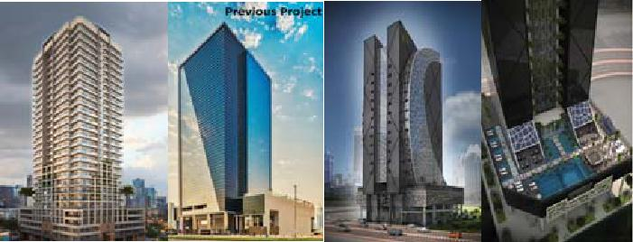

Dubai, UAE

- Job Designation: Project Engineer

- 2B+G+19+R+UR Canal Central Hotel Five Star in Business Bay, Dubai

- Project Value: 77,000.000 Dhs.

Responsibilities:-

- Overall Site organization, Supervision and coordination of activities, allocation of responsibilities to project.
- Carry out construction works in

accordance with construction program, method of statement and acceptance criteria defined by project specification.

- Shop drawing for Concrete and finishing works
- Quantity Surveyor for Concrete and finishing works.

- Casting all items (Foundation, Columns, Pile Cap, Retaining Wall, Slab etc.)
- Distribute all activity on Labour by productivity sheet

From 2014 - 2015

Egypt

Site Engineer

- Al Ain road 3000 Km Highway

- 8 Main lanes, 4 Service lanes, Bridges and tunnels

- Project Value: 12.000.000.000

Responsibilities:-

  - Follow all Post Tension works in Beams
  - Casting Foundation for Frame in Bridge
  - Compaction for Sand in Ramp in Bridge

  - Key stone system

