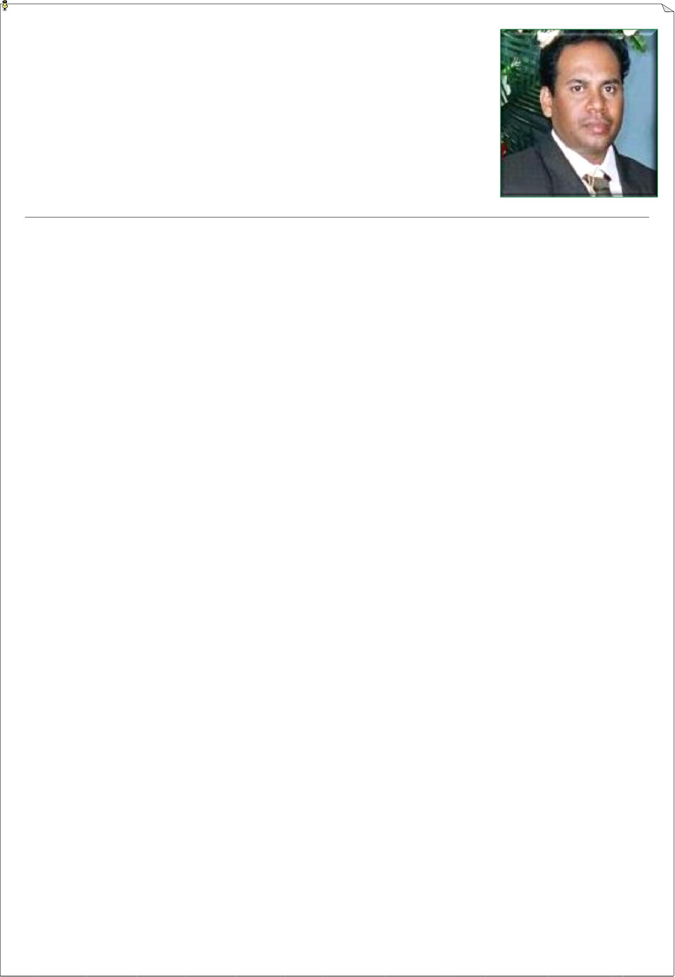
curriculum vitae

MR. ARUL
SRILANKA

Email: arul-395074@2freemail.com

PERSONAL INFORMATION:

 | Occupation | : Senior Technical officer in Civil Engineering
 | Sex | : Male
 | Age | : 47
 | Date of Birth | : 1971-08-27
 | Civil status | : Married
 | Citizenship | : Sri lanka
 | Nationality | : Sri Lankan Tamil
 | Religion | : Roman catholic Christian

Professional Experience (More than 19+ years in Civil Construction)

- Period: From November-1999 to November -2019.

- Designation: Senior Technical Officer in Civil Engineering

- Departments of Government Sector: State Government in Sri lanka

(Divisional secretariat at Valaichenai, Divisional secretariat at Kiran, Predeshiya sabha- Oddamavadi )

curriculum vitae

- Major Projects: (Estimation ,Architect Drawings ,levelling ,Consulting and payment bills were done by me to the following works)

  - Modern Children park, Const. of Market, Const. of Bus stand, Const. of Concrete road, Const. of Drainage and Drainage and cover Slabs under NELSIP project, Funded (100 Million) by World Bank Project (2010-2017). At Oddamavadi in Batticaloa.

2.Const. of Beautifications(5min) for Main road Rounder board and Inter lock paving to Market under ministry Allocation (2015) at Oddamavadi in Batticaloa.

- Const. Of Clock tower(5min.) at Oddamavadi main Road Junction (2018) in Batticaloa. under ministry Allocation (2015) at Oddamavadi in Batticaloa.

4. Const. Box Culverts, Hume pipe Culvers, Cause way at Oddamavadi, Kiran in Batticaloa.

- Const. of Tube well and Dug Wells at Kiran Division and Oddamavadi Division in Batticaloa.

- Const. of Bund for Irrigation tank, Multipurpose Buildings are implemented by District Secretariat and Major Irrigation (NEIAP), Minor Irritation Departments under World bank Project.

- 100 Nos. Housing Scheme project (100 Days Programme) under Sri lanka Government Project (2003) at Kiran Division in Batticaloa.

- Const. of Inter Lock Paving Road under R.D.A

- Const. Mosque and Concrete Retaining wall under Al-Hiqma N.G.O (3m Deep Foundation,2 stories Building near the River

- Const. of Concrete Retaining wall, Const. Of Gabion wall and Const. of Rubble wall. Under Sri lanka Government fund.

11. Resettlement, Reconstruction and Renovation works were done by me at Kiran Division in Batticaloa after ethnic war and tsunami 2004

- Architect drawings of 100 Nos Houses and Community Building was drawn by me. under EHED-Caritas (N.G.O) fund at Mylanpavali in Batticaloa

curriculum vitae

•Acting to : NEIAP (Irrigation Dept.) NCORD(Resettlement Dept.) A.C.L.G Office at Batticaloa.

•Consulting to: ZOA (N.G.O), ESCO(N.G.O), UNDP(N.G.O), World Food-UN, World Vision(N.G.O) , UMCOR(N.G.O), OXFORM(Australia) , PEOPLE IN NEED (N.G.O) For Pre-School Renovation , EHED and Caritas and Zam Zam Civil construction & Suppliers Ptv(Ltd) (150min. Tourist hotel Project at Pasikkuda in Batticaloa.)

Following works done by me in my above projects.

- Bill of Quantity preparations

- Surveying Levelling for Road, Drainage and land leveling

- Architect Drawings for Houses, Buildings, Drainage, Road, Clock tower, Children park.

- Power point presentation for work progress

- Site visit for work progress

- Investigation for Solid waste management system under UN project

- Registered as A Draftsman for Building at Municipal Council at Batticaloa (2007-2008)

- Checking all Building application of House holders

- Estimated for Metaling Tar, Concrete, Inter locking pavement Road, three

stories Building, Wells (dug &tub), Culverts, Drainage, Cover slab, Stadium ect.

Professional Qualification:

- N.C.T in Civil Engineering (Equal to N.D.T in Civil Engineering with 5 years experience )

- Diploma in AUTO CAD(2D,3D)

- Diploma in Revit Architecture

- Diploma in Computer Software

curriculum vitae

SKILLS

- Computer and other devices

- MS-Windows Xp , MS-Office packages, basic knowledge in graphic designing.

- Operating the multimedia projector

- Presentation skill

- Language – Spoken and written

- Tamil – Good, English – Good,

Note: *If want any documents with evidence, I can submit to.

*Senior Technical officer meaning is Assistant for Engineer

Declaration

I hereby declare that the above particulars furnished by me are true and accurate to the best of my knowledge.

Thanking You

Yours Faithfully

