CURRICULUM VITAE 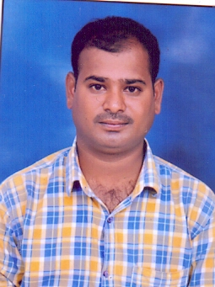

ANIL
DUBAI, UAE
Email : anil-395075@gulfjobseeker.com

Objective:
Seeking a challenging career in an esteemed organization where my talents can utilized for the growth of the company as well as self in an environment where team player role is significant and to be best be considered as an asset by employer. Learn, gain and implement.

Working Experience
+
Worked as a SYSTEM OPERATOR in HYDERABAD India. TWO YEARS

Educational Qualifications:

- DEGREE

Personal Profile

- Nationality : India
- Date of Birth : 16/08/1989
- Sex : Male
- Marital Status : MARRIED.

Languages known

- Hindi, English, Tlugu.

Passport, License & Visa Details

- Passport Expiry date : 08/10/2027
- Visa : Visit visa 90 days.

Personal Skill:-

- Sincere, honest and dedicated.
- Disciplined and sociable.
- Hardworking, self-motivated and result oriented.
- Ability to work under pressure.

Declaration

I hereby declare that all the information given above are true and correct to the best of my knowledge and belief.

ANIL

