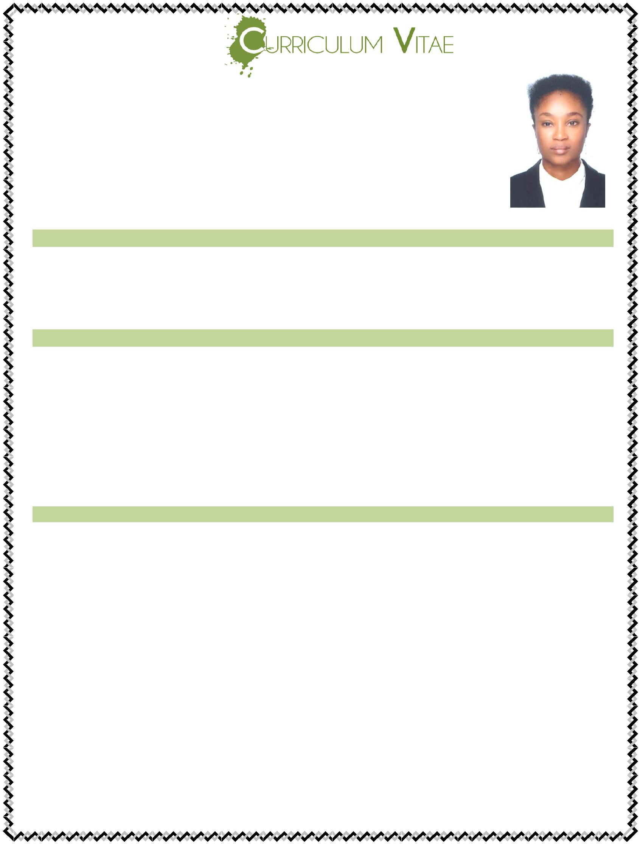

RUTH

Email: ruth-395079@2freemail.com

Dubai – U.A.E

OBJECTIVE:

A well trained and smart lady, seeking a position in reputed organization that will benefit from my initiative and hard work. Am interested in a position where acquired skill will be utilized towards continues growth and advancement.

WORK EXPERIENCE:

❖ Working as a cashier with Marry Brown in Dubai UAE ( Oct 2017 till date)
- Worked as a Class Assistant in a Private School ( 2015 -2016)

- Worked as a Cashier in a Pest Control company i n Dubai UAE ( 2014-2015)

- Worked Sales lady with Golden Penny Group of Companies Nigeria ( 2012 -2014)

DUTIES & RESPOSIBILITIES:

- Welcome customers.

- Help customers to locate products.

- Help customers to answer all necessary questions.

- Collect customer’s items and package them.

- Bill customers, collect payment and give receipts

- Make sure customers have an enjoyable time while shopping

- Assist customer in product selections based on their needs.

- Perform cash or credit card transactions for customer purchases.

- Balancing the account at the end of each day and prepares daily transaction report.

- Coordinate with suppliers to maintain requires stocks and delivery requirements.

SPECIAL SKILLS:

- Ability to work with minimal supervision

- Discretion and understanding the need for confidentiality

- Keep honest and clean records

- Good manner of approach towards people

- Patient with people of all character

- Ability to work as a team

- Self-motivated, enthusiastic and result oriented

- Physically fit and quick to learn and adapt.

PERSONAL INFORMATION:
❖ Gender | : | Female
❖ Date Of Birth | : | 08-01-1983
❖ Marital Status | : | Single
❖ Nationality | : | Nigerian
❖ Visa Status | : | Employment Visa
❖ Language | : | English

EDUCATION:
- Bsc (Accounting)

DECLARATION:

I certify that the above are true and correct to the best of my knowledge and ability. If given a chance to serve you. I assure you that I will execute my duties for the total satisfaction of my superiors.

