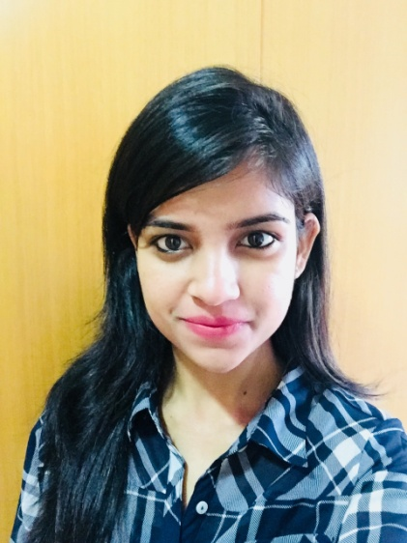

KABYA

E-mail ID: kabya-395118@2freemail.com

CAREER SUMMARY:
Seeking to acquire a responsible position as a digital marketing executive to bestow extension experience working in active environment and requiring strong organisational skills. Seeks a position with good interpersonal and time management skills and maintaining good relationships with the clients and colleagues in the work environment.
EDUCATION:
Trained in the World wide Mysore Infosys Global Training Centre Passing with HPF (High Performer) merit
2018
Bachelor of Technology, BPUT, CV Raman College Of Engineering,86% aggregate
2014-2018
12th Science, CHSE, Ravenshaw College, Cuttack, 78% aggregate
2014
10th ICSE, St. Joseph Girls High School, 94% aggregate,
2012
TRAINING ACQUIRED:
- Completed Business English Certification Course held by Oxford University by passing with merits.
- Training in CCNA.
- Trained in Python Language.
- Trained in HTML, CSS.
- Corporate behavioural skills and Soft skill specific training in Mysore passed with good credits.
- Acquired training at the world wide Infosys Mysore Training Centre.
- Trained in java and other scripting language in Unix environment.

TECHNICAL SKILLS:
- Languages Known: Python, Html, CSS, C, C++, Sql, Finacle scripting Language, Java.
- Proficient in MS Office (Word, Excel, PowerPoint, Access).
- Photoshop, WordPress knowledge.
- Idea about SEO, PPC, Google AdWords, social media marketing, email marketing and other marketing techniques.
- Internet and Emailing.
- Report making and documentation work.
- Database Management basics.
- Fast typing speed.
- Testing of the code, issue solving and smooth running of the project.
- Scripting in Unix environment and its usage.
- Well acquainted with both Unix as well as windows environment.
- Data structure basics.
- Preparing reports and reporting it to manager.
- Studying the requirements and the work environment and setting the goals accordingly and achieving it.

AWARDS AND RECOGNITION:
- Gold Medallist in essay writing Competition.
- First prize winner in debate competitions.
- First prize winner in inter college nukkad competitions.
- First prize winner in cooking competition.
- Won prizes in dance competition.
- Won award in ramp walk.
- Recognised in certain fitness programs.
- Anchoring in various cultural programs and events organised.
- Awarded in various Olympiads and Talent search competition held.
- Completed Marathon and was certified on behalf of World Aids Day.
- Worked as part of NGO team named HUM HAIN with other co-workers.
- Successfully completed training and merited as HPF (High Performer) in the training held at Worldwide Infosys Mysore Training Centre.

PERSONAL SKILLS AND RESPONSIBILITIES:
- Maintained healthy and friendly relation with the colleagues and other members in the MNC organisation.
- Attended all the meetings and trainings held from time to time.
- Studied the targets and achieved the goals within the deadlines.
- Fit and active all time with a fresh mind.
- Strong interpersonal communication skills that helped in the successful execution of activities.
- Ability to work independently and adapt to work environment as well.
- Research and execution abilities.
- Effective business correspondence with powerful interactions.
- Quick learning aptitude with analytical abilities.
- Strong network development capacities.
- Customer relationship management and public relations.
- Ability to work in a timely and accurate manner.
- Possess effective organisation and management skills.
- Can work under pressure and meet deadlines.
WORK EXPERIENCE:
Started in 21st May 2018 and and successful executed my role as a trainee in the Worldwide Infosys Mysore Global Training Centre in 11th September 2018 and then serving as a System Engineer in Infosys Ltd. Pune . I have been working here as a consulting advisor to communicate with the clients directly , maintain a good professional relationship with the ,maintain them under our customer list and crack deals and projects by communicating with them from onsite also and alongwith that guiding team and working as a team by distribution of the given task among each member and keeping attack of everything. I have also been working here since one year starting from 19th September 2018 under projects in Finacle banking Solutions where I had done development project like creation of APIs for online banking purposes in the Bank Dhofar of Oman and also in the core Project of Dhofar bank where I worked in Unix environment for creating menus for the bank and other porting and upgrade purpose and still continuing.

PERSONAL DETAILS:
- Gender: Female
- Date of Birth: 19-12-1995
- Nationality: Indian
- Marital Status: Single
- Languages known: Hindi, English, Oriya, Bengali

DECLARATION:
I, do hereby declare that the statements furnished above are true and correct to the best of my knowledge.

Kabya
Pune, Maharashtra
India.

