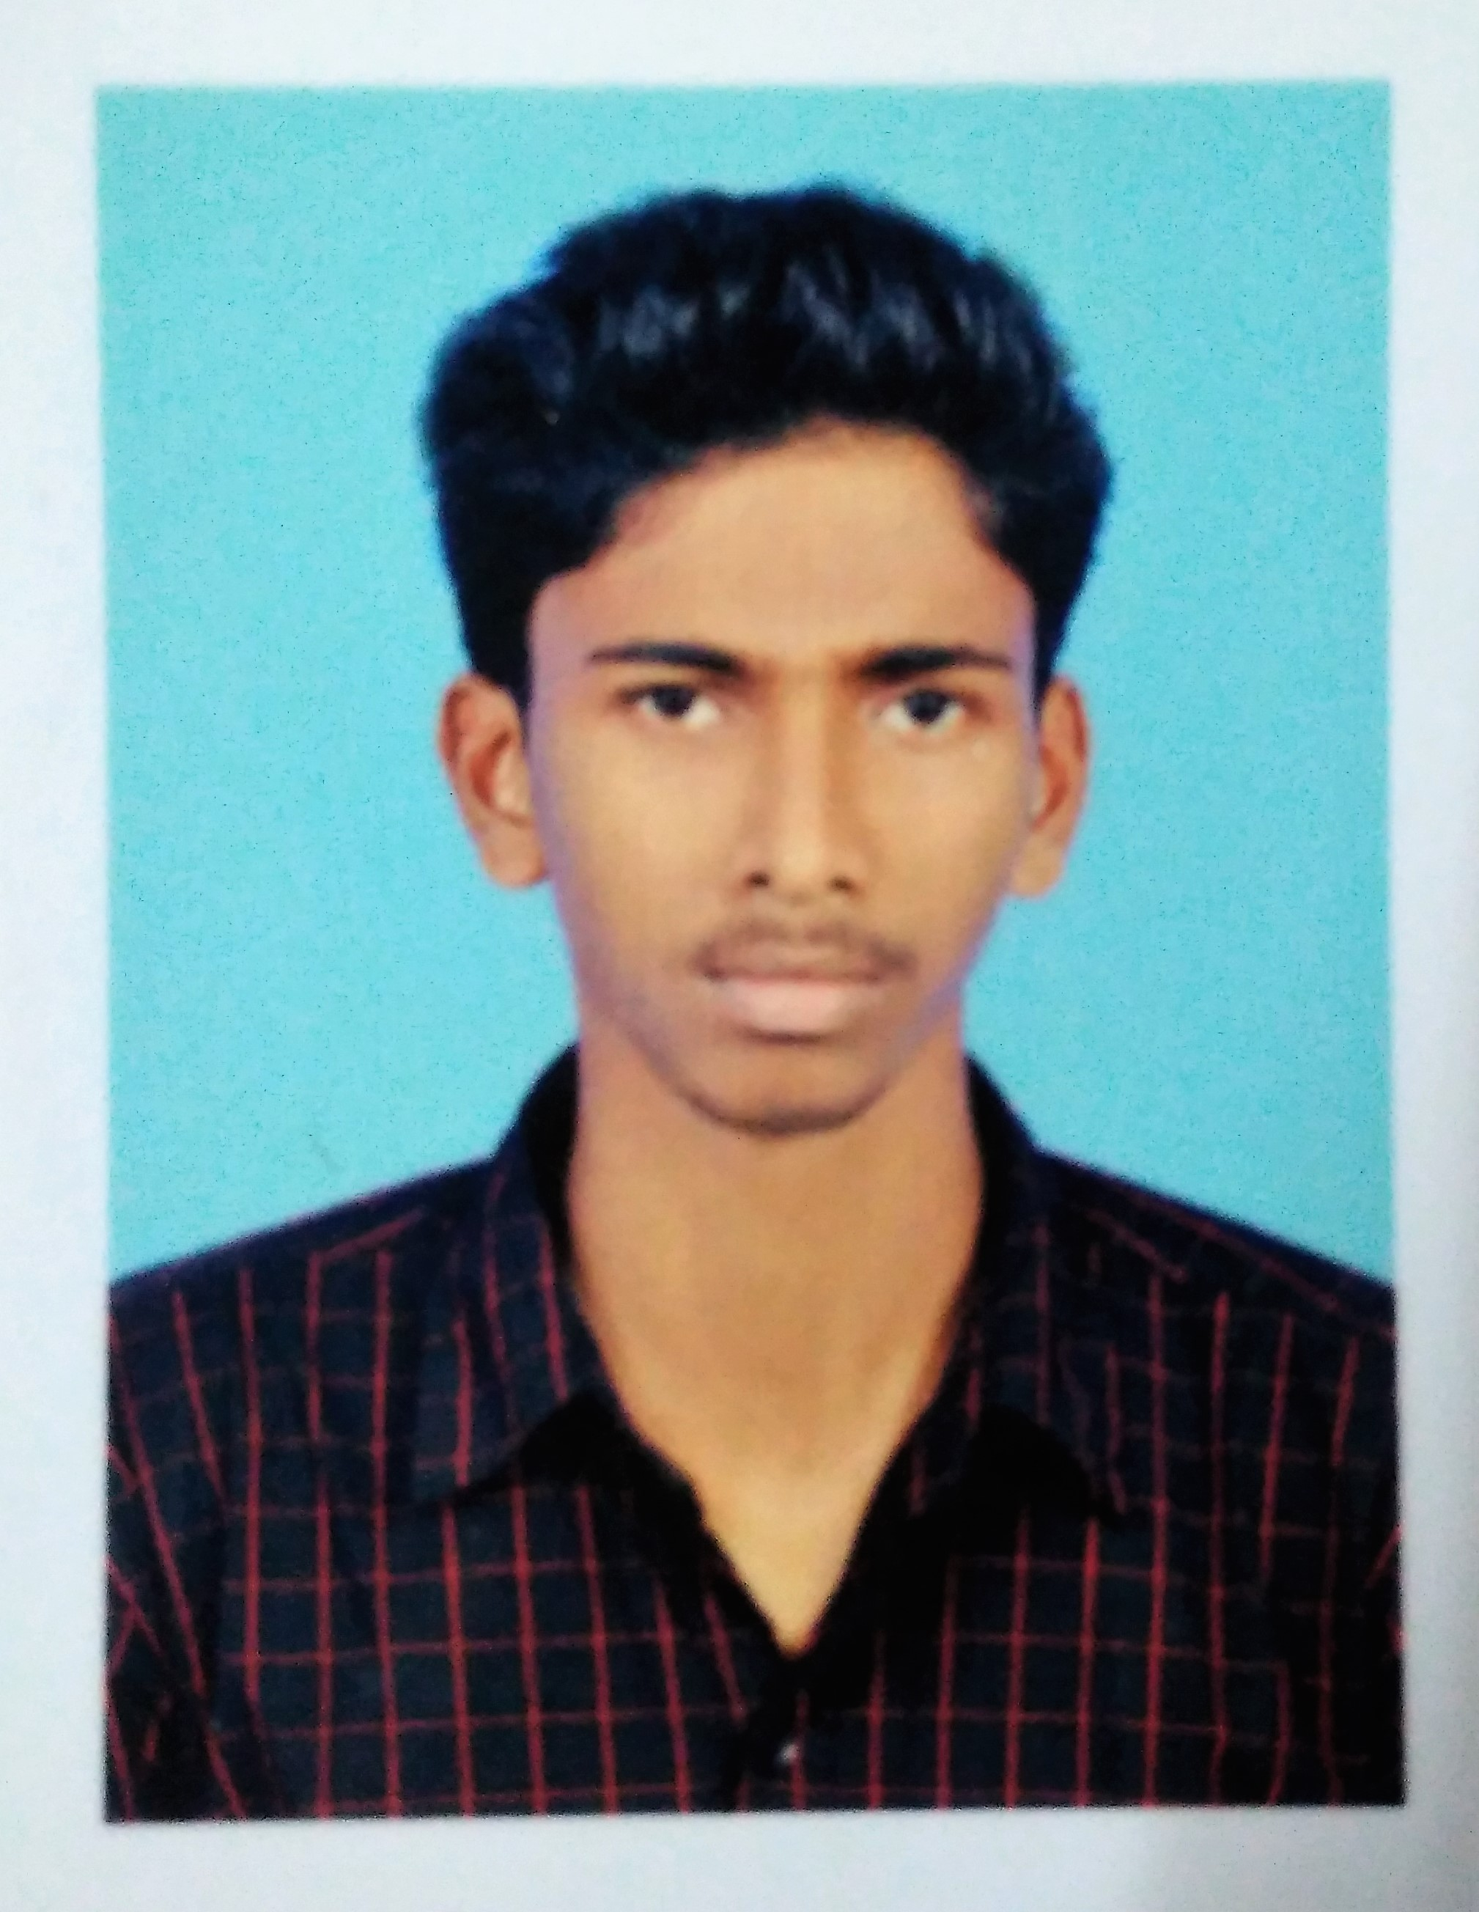  ASHIL P  Electrical Engineer  ashil-395119@2freemail.com  ACADEMICS  Graduation:  Bachelors of Technology  Specialization:  Electrical & Electronics  Engineering  College:  AWH College Of Engineering  & Technology, calicut, kerala, India.  University:  CALICUT University,  Kerala, India.  COMPUTER SKILLS  - MS Office 2010 (MS Word, MS Excel, MS PowerPoint)  - Microsoft Windows Operating Systems XP/7/8/8.1/10  PERSONAL DETAILS  Name : Ashil  Date of Birth : 24-08-1993  Gender : Male  Nationality : Indian  Marital status : Signal  Languages known : English and Hindi and Malayalam  PERSONAL STRENGTHS  - Good Communication Skill  - Self Confidence  - Eager to Learn  - Leadership  - Loyalty | CAREER SUMMARY  - An experienced Electrical Engineer in valuable Projects, 2 years of experience in Construction.  - An exceptional track record in reputable organization, seeking a challenging and professionally rewarding position.  - Abilities to work in Design & Engineering.  - Willing to work as a key player in a creative environment.  WORK EXPEIENCE : INDIA  Designation : Electrical Site Engineer  Date : From April 2016 to April 2018  Project name:RAPDRP -CALICUT  - Execution of Works for Augmentation of Distribution System in Kozhikode City under Part-B of R-APDRP Scheme.  CLIENT: Kerala state Electricity board  - In this project Electrical system Erection of new distribution transformer and DP structure including cable tray ,AB structure and distribution&control boxes.  - Testing and commissioning of distribution transformer and OH line(LT&HT) by ensuring standard electrical connection measures.  - Installation of capacitor bank and automatic street light control timer switch on various transformer structure.  - Execution and commissioning of works by implementing proper safety procedures.  - Construction and reconductoring of 11KV HT OH line .  - Construction ,1 phase to 3 phase conversion and reconductoring of LT OH line.  - Material issuing,daily progress documentation and measurement of work done at respective site and enduring the check list of work.  - Pre task planning,PTW(permit to work) arrangement and site supervising as per the company standard.  - Surveying and inventory of sites with pre execution planning.  - Erection and dismantling of electric poles with standard measures(including pit excavation and concreting) with proper pole earthing.  - Preparation of BOQ and material reconciliation.  JOB RESPONSIBILITIES  - Documentation - Prepare and review to submit the document for pre-qualification approval, Material approval, Shop Drawing, Method statement & Operation & Manual based on the project specification.  - Material management – Selection of Material with following standards BS, NEC & IEEE.  - Site Execution – Daily follow the site work to complete Electrical works to execute the project as per the Specifications and applicable standards. Supervise Monitor & Get approval in all activities of installation, Testing and commissioning with applicable method statement. Need necessary coordination with all other related services for the effective and smooth completion of the project as per the schedule. Modifying Drawings and preparing Request for Information over critical issues.  - Safety - Awareness of all kind of Electrical installations in industrial, Residential High rise building property.  DECLARATION  I hereby declare that all the statements mentioned above are true to the best of my knowledge and belief.  Place : CALICUT ASHIL

