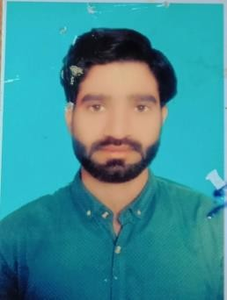
RESUME

ABUZAR
OBJECTIVES

To obtain meaningful and challenging position that enables me to learn and contribute in the field of Tool Room Work and allows for carrier advancement.
Email ID& Contact No ;

Email:
Abuzar-395122@2freemail.com

Contact Details
00 971 50 1486215

PERSONAL DETAILS
Date of Birth : 10nd SEP 1995
Sex
: Male
Nationality : Pakistani Marital Status : Single Father’s Name : Farooq Saeed
Visa Status . Visit Visa-3 Months (Transferable)

AREAS OF INTEREST
Tool room maintenance work and create a new job work
EDUCATIONAL QUALIFICATION:

- Completed Diploma of Associate Engineer Mechanical (With Dies & Moulds) from Precision System Training Center (Pcsir) Lahore in 2015.

- Completed Metric from Board of Intermediate & Secondary Education,Gujranwala in 2010.

CORE COMPETENCIES:

Maintenance Work
- Accept the job
- Find the fault.and problems
- . Identifying the right problems of mould and dies & solved the problem.
- Create a new job and fitting the mould and die.
- Reapir all kinds of moulds ,injection moulds,blow mould,and thermoforming moulds

KEY SKILLS:
- Hardworking & Fast Learner
- Good Knowledge & experience in team player &ability to learn quickly & adapt to changing environments.
- Attention to detail.
- Eligibility to work under pressure.
TECHNICAL SKILLS
- Diploma in Cad Cam
- Operate of all manual machines

WORK EXPRIENCE
- Synthetic Products Enterprises Ltd.

Aug 2015 – Aug 2016
Designation : DIE Fitter Location : Lahore Pakistan Responsibilities
- Assembling Matching,Polishing,and Fitting.
- Using Grinds,Files,sand,and polishes of metal working die member to specify shaps and smoothness inspect dies.and hand tools.
- Operate of all machines manual (Lath,Surface grinder,Shapeer,Milling, Cylindrical Grinder,and Drill Machine
- Preparation of work report

Arabian Plastic Industrial Co Ltd

April 2017 – April 2018.
Designation : Tool Room Techanician Location : Jeddah, K.S.A. Responsibilities
- Assembling Matching,Polishing,and Fitting.
- Using Grinds,Files,sand,and polishes of metal working die member to specify shaps and smoothness inspect dies.and hand tools
- Operate of all machines manual (Lath,Surface grinder,Shapeer,Milling, Cylindrical Grinder,and Drill Machine
LANGUAGES KNOWN
- To Read, Write and Speak
- English, Urdu.

HOBBIES
- Watching news, Movies and cricket

DECLARATION

I hereby declare that all the statements made in the above resume are true to the best of my knowledge and belief.

ABUZAR

Signature:

Date:

