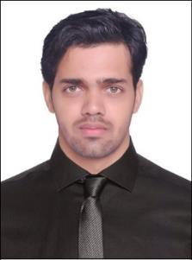
Curriculum Vitae CHANDAN

Mail Id: chandan-395128@2freemail.com

OBJECTIVE

To require a job in reputed organization with singular objective to accomplish the task assigned with full of diligence, dedication and take the target with extreme seriousness as mission to be accomplished.

VISION

To deliver my ability and competency in the field assigned and reach the standard optimum level required, with the fullest of my efficacy.

EDUCATIONAL QUALIFICATION
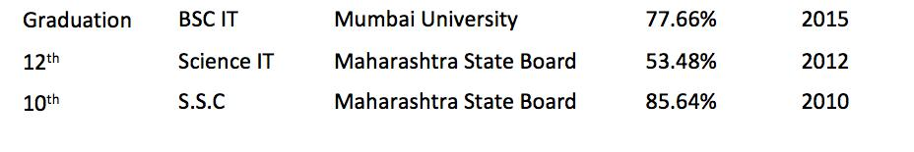

PROFESSIONAL QUALIFICATION

- Extensive 5 years of technical experience earned in IT sector while providing support for IT core business solutions projects
- Certification of Microsoft Certified Systems Administrator (MCSA), course accredited by Microsoft Incorporation, successfully completed in 2016,

- DBA (SQL Database Administrator) qualified in 2016.

- Certification of Cisco Certified Network Associate (CCNA) course accredited by Cisco Incorporation, successfully completed in 2018,

WORK EXPERIENCE

(Jan 2018 – Current)

IT Support Engineer | Dubai, UAE

- Handling all Bank branches in all over UAE.

- Installation, configuration and troubleshooting Remote advisory device.
- Installation, configuration and troubleshooting of Clients Windows 7 / 8

/10 and MAC users.

- Handling 30 to 40 users daily for O365 and Outlook issues.

- Installation, configuration and troubleshooting of Desktop, Laptops and Surface Pro.

- Installation, configuration and troubleshooting of Banking Systems Setup.

- Network printer and scanner driver installation and configuration.

- Adding workstations to domain, upgrading antivirus and patch updates.

- Installing and resetting of cisco IP phones.

- Working and supporting for VDI (virtual desktop interface) users.

- Installation, configuration and troubleshooting of company required applications and settings in Tablets, Phones and I Pad.

- Working and supporting for Office 365 users.

- Instillation and configuration of Outlook, In-Tune for mobile access mail from anywhere.

- Cloning of Hard drives in bulk and Hardware parts replacement like HDD, RAM, and Network card, Increase Paging of RAM.

- Instant card and chequebook printing machine installation and configuration.

- Remotely accessing client's computer and performing all necessary installations.

- Installation and troubleshooting of browsers like IE and chrome, Java and proxy related issue.

- Installation, configuration and troubleshooting of ICCS Scanner and Application.

- Installation, configuration and troubleshooting of Newgen Omni Scan and Flexcube for banking application

- Network printers configuration. (Xerox, HP, KONIKA MINOLTA)

- Weekly branch visit in Digital Branches, preparing checklist and troubleshoot the issues and fix.

(May 2016 – Nov 2017)

Desktop Support Engineer Level 2 | Mumbai, MH

- Remotely accessing client's computer and performing all necessary installations

- Managing and maintain of Routers, switches and connection
- Installation, configuration and troubleshooting of windows Servers 2012/2008 and Clients Windows XP/ 7 / 8 /10.
- Managing and Maintaining of Sever 2012 and Active Directory, DNS, DHCP and Server Performance, Health Check, Group Policy Management.

- Installation, configuration and troubleshooting of Local and Network Printer

- Installation, configuration and troubleshooting of Smart Cop Antivirus Server and Client

- Performing administrative task like resetting windows login IDs and password of domain users.
- Installation & Troubleshooting of various browsers like IE, Chrome, Firefox, etc.

- Supporting and troubleshooting Internet and LAN/Proxy Connectivity issues.

- Installation, configuration and troubleshooting of MS Outlook with Exchange Server, POP3 Servers.

- Installation & Configuration of Cisco Video Conference setup and Set-up Video Conference /projectors for presentations in meeting rooms.

- Performing System maintenance and backups in weekends
- Configuring backup for servers and routine checkup for the backup process and Checking the backups and restore the data for data validation
- Deploying OS through WDS- Backup and restore the system state and

Image backup or Client/Server.

- Training end users on functions of hardware and usage of new software applications.

(March 2014 – Oct 2015)

IT Engineer | Mumbai MH

- Handled up to 20 support requests per day.

- Resolved virus and malware issues with a 95% success rate.

- Performed testing and problem analysis for server, desktop, and IT infrastructure.

- Prepped new laptops and desktops for deployment, installed software and operating systems.

- Backed up and restored data, operating systems, files, and drivers.

- Managed call flows and prioritized response efforts.
- Utilized diagnostic tools and strategies to solve technical issues and provide preventative maintenance.

- Travelling to client sites to help with installs, deployment, and troubleshooting.

- Management of the daily data backup and retrieval scheme.
- Installing and operating Windows desktop and server operating systems. TCP/IP networking and hardware maintenance and repair.

ROFESSIONAL SKILLS

- Excelled in Installing, upgrading Windows and MAC OS in authorized desktop applications, hardware, and various in its peripherals.

- Able to resolve daily technical issues and providing L1, L2 and L3 support

- Ability to work in a team and independently.

- The ability to priorities your workload.

- Ability to work with minimal supervision and to take initiative always.
- Performed excellently well in providing troubleshooting services in both the stream i.e. Software and hardware while working onto networking issues.
- Excellent in developing in system and security documentation.
- Create alternative methods of completing tasks, correcting user
errors and system inconsistencies to improve the desktop team function.
PERSONAL INFORMATIONS

Date of Birth

Marital Status
Nationality
Languages Known

Visa Status
Passport Expiry

: 17th July 1993
: Single
: Indian
: English, Hindi & Marathi
: Employment Visa
: 23rd. November 2025

DECLARATION

I hereby declare that the information furnished above is true to the best of my knowledge.

Dated

Place

(CHANDAN)

