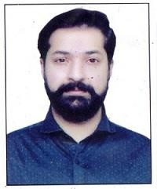
MALIK

Email: malik-395140@2freemail.com

OBJECTIVE

To work in an organization as an integral part of it and accomplish the job assigned in a better way. I’m looking for a highly challenging and dynamic work environment in which i will be able to enhance my professional skills and would be able to get valuable work experience

EDUCATIONAL CAREER

B.A
SARGHODHA UNIVERSITY 2016

BISE RAWALPINDI
INTERMEDIATE (Pre-Eng) 2011

BISE
SSC/MATRICULATION(SCIENCE)2009

PERSONAL INFORMATION

DATE IF BIRTH 29 NOVEMBER,1993
MARTIAL STATUS SINGLE RELIGION ISLAM
NATIONALITY PAKISTANI
DOMICILE PUNJAB (RAWALPINDI)
LANGUAGES ENGLISH, URDU

INTERPERSONAL SKILLS

Team Work Spirit & Motivation
Energy Enthusiasm And Motivation To Wok Hard Excellent Communication Skills
Abilities To Make Other Understand Own View Point

EXPERIENCE

I have 03 years experience in as police officer in punjab police Rawalpindi Pakistan
I have 02 years experience as manager in sholay grill restaurant
I have 01 year experience as a senior manager in THE FOOD FOREST

COMPUTER SKILLS

Basic computer [Ms Office] Ms word

REFRENCES

WILL BE FURNISHED ON DEMAND

