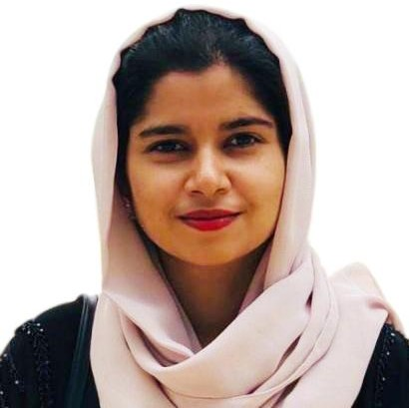

Fathimath
Email Address: fahimath-395149@2freemail.com

Objective:
To pursue a challenging career with a dynamic organization that provides continues learning & opportunity, to utilize my knowledge and skills, abilities to enhance my potential for organizational & personnel growth.

Work Experiences:
Accolade Tech Solutions
India (June 2016 to Oct 2018)

Software Developer
- Specific Duties and Responsibilities:

  - Designing and developing of websites, desktop and web applications.
  - Programming experience with web technologies like .NET c#, HTML, CSS, JavaScript and Web services.
  - Worked on ASP.NET Ajax Extensions and Toolkit controls.
  - Knowledge of SQL and extensive scripting experience in coding stored procedure Functions and Triggers using MS SQL Server 2008.
  - Worked in database design on MySQL query browser and development of different database objects containing functions and triggers.
  - Work experience in Improve existing software, Revise, update, refactor and debug code.
  - Guided many internship projects and was responsible for their completion of projects
  - Analyzing and resolving technical and application problems.

Skill Summary
  - Good understanding of object-oriented programming concepts
  - Good understanding of relational database design and querying concepts
  - Effective communication, analytical and interpersonal skills with the ability to maintain good relations and share technical ideas with users, clients, technical and management staff.
  - Excellent leadership and mentoring skills as well as the ability to work independently and within teams.
  - Strong organizational skills along with the ability to accomplish multiple tasks under pressure and meet specific deadlines.

Technical Skills
  - Programming Language : C#.Net, Html, CSS, JavaScript.
  - DBMS/RDMS : MySQL, SQL Server.
  - Software : Asp.net.
  - Mobile Application Development : Android.
  - Other Technical Skills : Adobe Photoshop,Knowledge in Microsoft office applications.

Education
Graduation 2013 - 2016 Bachelor of Computer Application
St. Philomena College, Puttur (University of Mangalore) Karnataka, India

PUC-(PCMB) 2011 - 2013 Higher Secondary School Leaving Certificate
St. Philomena PU College, Puttur, Mangalore Karnataka PU Board, Karnataka– India

SSLC March 2011 Secondary School Leaving Certificate
RHS School, Kajoor, Karnataka - India
Karnataka Educational Board, Karnataka - India

Languages Known
English, Hindi, Malayalam, Kannada, Arabic (beginner)

Personal Information

Civil Status : Married
Date of Birth : 26th Sep 1995
Nationality : Indian
Sex : Female
Religion : Islam
Visa status : Visit Visa

Declaration:

I hereby declare that the above information is true to the best of my knowledge.

Date: 06/08/2019 Sincerely,
Place: Sharjah Fathimath

