RESUME
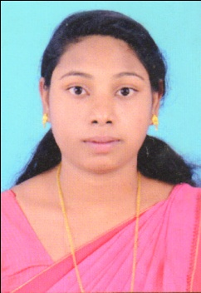 BETZY
Betzy-395169@2freemail.com
- PERSONAL DETAILS
Name : Betzy
Religion& caste : Christian Orthodox
Age &Date of Birth : 24, 13/01/1994
Nationality : Indian
Sex : Female
Mother Tongue : Malayalam
Language Known : Malayalam, English & Hindi
Marital status : Married

EDUCATIONAL QUALIFICATIONS

B-Ed CTE, Kumily 2017 -2019 -87%
B.A St . Dominic’s College,
Kanjirappally 2011-2014 -67%
Plus-Two CKMHSS, Koruthodu) 2009-2011 -72%
SSLC CKMHSS, Koruthodu) 2009 -65%

DECLARATION
I hereby declare that the above-mentioned informations are correct up to my knowledge and belief and I bear the responsibility for the correctness of the above-mentioned particulars.
Date :

Place : Chakkupallam Betzy

