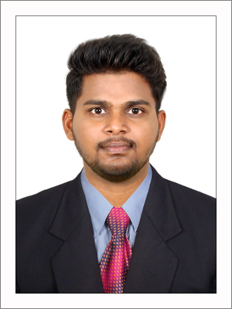

POTHIRAJ

E-mail: pothiraj-395244@2freemail.com
Location: Al-Karama,Dubai

Objective
To work in an organization which gives me a chance to enhance my skills and bring out the best in me and to satisfy the requirements of the concerned organization to meet the needs of the industry and equip myself with the latest available technology.

Educational Qualification
Qualification | Institution | Percentage/  CGPA | Year of  passing
BE | Kamaraj College Of Engineering&Technology,Virudhunagar | 6.41 | 2018
DCE | MSPVL Polytechnic College,Pavoorchatram | 88 | 2015
SSLC | Government Higher Secondary School,Chatrapatti | 66.8 | 2012

Work Experience
- Designation :Junior Engineer
- Company :ENGINEERING COMPANY in Chennai
- Duration :May 2018 to Sep 2019 (1 Year 4 months).

Project Details
- Project Name : Hazel Reality Pvt.Ltd
- PMC :FABS
- Project value: 200Crs
- Construction of multi-storied apartments having one basement and S+14 floors, having 6 similar towers.
- Total: 781 flats of 1, 1.5, 2 & 3 BHK flats.

Roles &Responsibilities
  - Executing the work as per the received GFC drawings without anydeviation
  - Maintaining the DLR & DPR reports for the daily work done calculation
  - Regular checking of the Quality of the work done by labours& giving PEPtalk before starting newactivity
  - Getting the check list signed from the PMC before starting any activity
  - Maintaining the checklists for all activities to claim the clientbill
  - Preparing the Monthly labour bills and maintaining the record of the % ofbills released
  - Preparing the monthly reconciliation statement of the bulk materials used likecement,sand to avoid the wastage & miscellaneous
  - Studying of working drawings, BOQ and contract document. (Findingthe specification of item of work has deviated from theactual).

Software Skills
  - Auto CAD, MS Office,Primavera P6(Basic)

Languages Known
  - English,Hindi,Tamil

Personal Information
  - Gender : Male
  - D.O.B :11.01.1997
  - MaritalStatus :Unmarried
  - Nationality : Indian
  - Visa Status : Visit Visa(90days)

Declaration
I declare that the information herein above given by me are true and given to the best of my knowledge and belief.

Place :YoursSincerely
Date : (POTHIRAJ)

