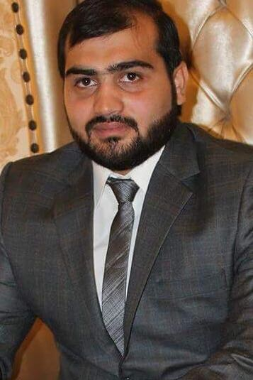
DR.HAFIZ
DVM Scholar, (UVAS)

Email: hafiz-395265@2freemail.com

OBJECTIVE

Fulfillment of given responsibilities with sincerity and dedication to seek respectable status and to become active and leading part of a reputable organization where I can nourish my practical skills. I am eager to work and to express my abilities for the uplift of economic status and reputation of the organization in industry.
PERSONAL INFORMATION

- Date & Place of Birth: DEC-10-1992
- Marital Status: Single
- Domicile: Lahore , Punjab

ACADEMIC QUALIFICATION

- D.V.M : University of Veterinary and Animal Sciences
2011-2016(UVAS) Lahore, Pakistan

- F. Sc (Pre-Medical): GCU Lahore

(2009-2011) 894/1100 (83)

- Matriculation: Govt. central model,lower mall, Lahore

(2009) 948/1050 (90.2%)

Experience

- 8 years teaching experience as a Biology Teacher
- 3 years teaching experience as a Biology Teacher at The Educators City Campus
- 2 years teaching experience as a Biology Teacher at Al- Noor College Shahdara
- 3 years teaching experience as a Biology Teacher at Kips Preparation
- 3 years teaching experience as a Biology Teacher at Sheraz Academy

personal atributes

Excellent communication skills as a teacher and a reprsentativeExcellent diagnostic skills in poultry and ability to implement effective treatment effective treatment plans for quick and economic recoveries.
Ability to work quickly and effectively under pressure.
Detail oriented
Strong quantitative and analytical skills.
Ability to organize and prioritize workload effectively.
Ability to work independently or in a team work.
Excellent public relations skills, interpersonal skills.
COMPUTER SKILLS
- Windows Operating System (XP)
- Microsoft Office 2003, 2007 (Word, Excel, PowerPoint)
LANGUAGES
- English
- Urdu
- Punjabi
REFERENCES

- Will be provided on demand.

