CURRICULUM VITAE
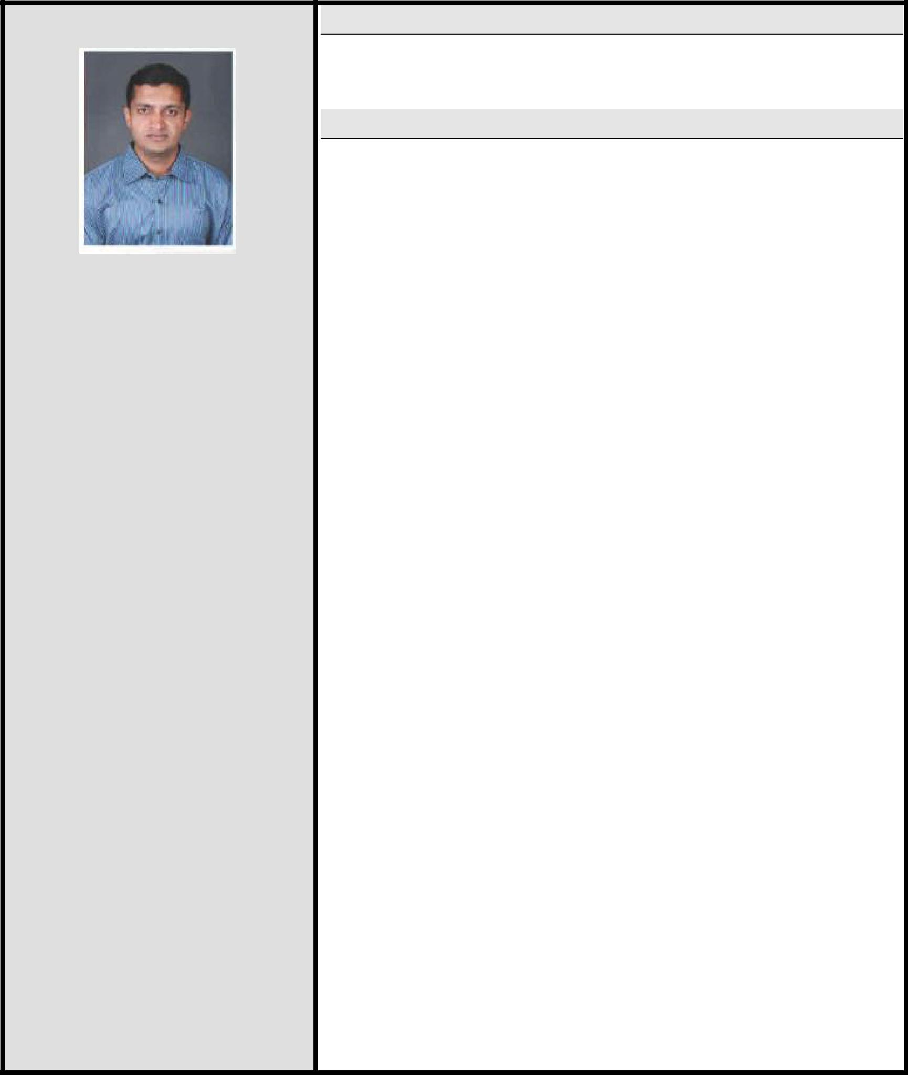

YOGESH

.

E-mail ID:

Yogesh-395267@2freemail.com

Software acquaintances:

- AUTO CAD,MS-office.

- Stadd pro.

- MSP & Oracles Primavera.

Personal Data:
Date of birth: |  | 24th August 1987
Marital status: |  | Single
Nationality : |  | Indian

Career Objective

To creatively use my skills and my potential in the best interest of the organization, simultaneously expand my knowledge and capabilities.

Career Experience

Total Experience: 8 Years 3 Month. (Gulf- 4 Years 5 months till date) (India- 3 Years 8 Months)

- Experience: 2 Years 4 Months (From 17th June 2017 to Till Date.)

Name of Company: Contracting Company in Qatar.

Location: Doha Qatar

Designation: Civil Site engineer.

  - Site location and description: Main works for Lusail Stadium, Lusail Qatar.

Client:-Supreme Committee for Delivery and Legacy.
Project Management:- Time Qatar.

Consultant:- Louis Berger.

- Job profile:

    - Ensuring that the Forman, charge hand, workers & Sub-contractor understanding their area of responsibilities & carrying out their given task efficiently & diligently to achieve the objectives of the project.

    - Monitor personally the proper usage of manpower, equipment & materials & the smooth running of the works as per schedule. Plan requirement of manpower equipment

      - materials & monitor timely availability of the resources at site with the approval of the Construction Manager/ Project Engineer to ensure the work progress without hindrance.

    - Maintain relationship with clients representative & Consultants at site & ensure quality work as per specification & keep proper record of variation orders & site instructions.

    - Record & submit measurements of work done at site to the Project Manager to submit monthly valuation to the client in time. Prepare monthly payment certificate of sub-contractors
      - piece workers & submit to Project Engineer on time.

    - Establishing & enforce project safety rules in accordance with concretion industry safety standard.

Passport details:
Place of issue: BANGLORE, INDIA.
Date of issue: 12.09.2018
Expiry date: 11.09.2028

- Experience: 2 Years 2 Months (From 14th Jan 2015 to 30th March 2017)

Name of Company: DURAT AL SAHIL SERVICES & TRADE LLC.

Location: SULTANATE OF OMAN

Designation: Civil engineer.

  - Site location and description: Construction of 16 classrooms mixed basic education school (1-10) at Al-Muodeera, Wilayat Muhoot Wusta Governorate situated at sultanate of Oman.
Client:-Ministry of Education sultanate of Oman.
Consultant:-Al-MeedaniaEngineeringConsultancy.

(Duration:- 25-01-2015 To 16-02-2016)

- Job profile:

    - Execution of the work on site as per given Drawings and details. Took responsibilities to complete the project in time and with quality.

    - Checking the quality of the materials at site.

    - Checking of the shuttering work and steel of structural members before concreting.
    - Raising SRM on time.

    - Preparation of bar bending schedule.

    - Daily Reporting like DPR, DMR, Daily Production report.

  - Site location and description: 600 KDL Sewage & Tertiary Treatment Plant at Regional Head Quarters Complex at Ibra situated at sultanate of Oman.

Client: - Royal Oman Police.
Consultant:-Directorate general of projects and maintenance

sultanate of Oman.(Duration: - 04-04-2016 to 14-10-2016).

Job profile: Same as above.

IV. Site location and description: 300 KDL Sewage & Tertiary Treatment Plant at Regional Head Quarters Complex at Buraimi. Situated at sultanate of Oman.
Client:-Royal Oman Police.
Consultant:-Directorate general of projects and maintenance

sultanate of Oman. (Duration: - 20-10-2016 to 22-03-2017).

Job profile: Same as above.

- Experience: 2 years (From June 2012 to – May 2014):

Name of firm: S.A.KANGRALKAR ASSOCIATES

Location: PUNE, INDIA.

Designation: Junior Site Engineer.

  - Job profile:
    - Execution of the work on site as per given drawings and details.

    - Took responsibilities to complete the project in time and with quality.

    - Checking of the shuttering work and steel of structural members before concreting.

    - Maintaining all the registers up to date like steel consumption, cement consumption, DPR, etc

- Experience: 7 Months (From June 2014 to – Dec 2014):

Owen Construction Business (Consulting)

Location: BELGAUM INDIA.

  - Job profile: Drafting & Detailing Drawings. Estimation & costing. Preparation of bar bending schedule. Daily site Visit & Supervising. Billing.

- Experience: 1 Year 3 Months (From May 2008 to – July 2009):

Name of firm: R.J. INFRABUILD

Location: BELGAUM INDIA

Designation: Junior Civil Engineer.

  - Job profile: Preparation of bar bending schedule. Drafting &

Detailing Drawings. Checking of the steel of structural members on site before concreting. Maintaining all the registers up to date like steel consumption, cement consumption, DPR, etc.

Educational Background

- Engineering:

College: Government Engineering College, Raichur Karnataka.

India.(VTU,BGM)

Discipline: B.E (Civil)

Degree Percentage: 59.44 %

Year of passing: 2012

- Diploma in Civil Engineer:

College: R.N. Shetty Polytechnic college, Belgaum Karnataka India.

Discipline: Diploma In civil Engineering

Degree Percentage: 64.74 %

Year of passing: 2008

- Post-Graduation:

College: National Institute of Construction Management & Research.

(NICMAR)

Discipline: Post Graduate Program in Construction Management.

Degree Percentage: 54.17 %

Year of passing: 2018

ACHIEVEMENTS

- Best Engineer of the Month in Lusail Stadium & Precinct (January 2018).

- Outstanding site Employee for Lusail Stadium & Precinct Project & is Recognized by Lusail Stadium & Precinct.

- Appreciates the Contribution & Commitment of towards achieving 5 million manhours without LTI Lusail Stadium Precinct project for Lusail stadium FIFA 2022 Football world cup.

Extra-Curricular Activities

- Completed Course Working at Height.

- Completed Course Confined Space.

Languages Known

1. English. 2. Hindi. 3. Marathi 4.Kannada

Affirmation

I hereby declare that all of the above-mentioned information is accurate to the best of my knowledge and ability

Date: 20.10.2019 YOGESH

