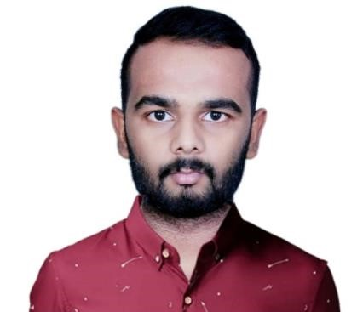

DANESH A
E-Mail: danesh-395285@2freemail.com

CAREER OBJECTIVE
To be an astute learner and the best performer in your organization. So that can build an innovative career in your esteemed organization by using my skills and other significant talents.

ACADEMIC QUALIFICATION
Name of the course | Name of the Institution | Board/University | Year of passing | Percentage  of  Marks
B.E(AUTOMOBILE ENGINEERING) | Paavai College of Engineering, Namakkal. | Anna University | 2012-2016 | Not Completed
HSC | SKV Higher Secondary School, Nammakal | State Board | 2011-2012 | 72.3
SSLC | SKV Higher Secondary School, Namakkal | State Board | 2009-2010 | 92

AREAS OF INTEREST
- Production
- Maintenance
- Management
- Sales
TECHNICAL PROFICIENCY
- MS Office

PROFESSIONALWORKEXPERIENCE
● ADMINISTRATIVE OFFICER
(Sep 2016 – May 2017)
- Maintained contact with companies to communicate tomaximize service performance.
- Managed administration and accounts.

● HR ADMINISTRATOR
( June 2017 – Dec 2018)
- Maintained event plans, selecting venues, arranging event services.
- Maintained the up keep of all incomingand outgoing employee verifications, unemployment worksheets, and termination letters to agencies.
● SALES EXECUTIVE
(Dec 2018- July 2019)
- Developed new promotional campaign by bundling products together (Cashew and Almond)
- Negotiated new contract with vendors and increased sales revenue
- Dealt with customer queries; analyzed precise ongoing market analysis and valuation of competitors and looked out for unique ways to enhance sales.

PERSONAL PROFILE
Date of Birth : 10.05.1995
Blood Group : O+
Father’s Name : Mr. Anand
Nationality : Indian
Languages Known : Tamil, English (speak, read and write)Hindi, Malayalam(can speak)

Visa type |  | : Tourist visa

DECLARATION
I hereby declare that the above furnished information is true to best of my knowledge.

Date: 28.09.19 Place: Sharjah, UAE

